The ‘Electronic Teacher’ – User Guide

ET Version 2.0 Date: 25/02/03

ET2 is an integrated package aimed at recording, monitoring and analysing student performance within a particular class/group, giving the teacher/lecturer instantaneous feedback and clearly indicating exceptional performance.

It also facilitates the creation of detailed, comprehensive, individual reports.

ET will help you raise standards and reduce your workload - all at the same time!

Minimum System Requirements: 400MHz Processor, 64Mb RAM, Windows ’95, Excel ’97 and Word ’97

ET is comprised of six modules:

- Automated Markbook
- Analysis And Support
- Qualifications Markbook
- Automated Register
- Report Writer
- Progress Tracking

Automated Markbook

ET’s Markbook module allows you to record raw scores for up to six user-definable types of assessment. Any types of assessment and any types of score can be used:

Assessment:

Generic: Behaviour, Effort, Achievement, Routines….
Specific: Analysis, Design, Implementation, Testing, Evaluation…
Diverse: Primary Maths, Primary English, Primary Science…it’s up to you!

Scores:

Increasing, decreasing or static numbers
GCSE, GCE letter grades (A*, A, B…)
Letters grades with + and – signs (A+, A, A-, B+….)
National Curriculum grades (1a, 1b, 1c, 2a…)
Greek, Arabic, whatever…you choose!

ET’s Markbook instantaneously calculates and updates:

Individual, group and topic averages for all chosen assessment types
Individual value-added performance based on user-defined assessment type
Identifies positive and negative exceptional performances
Topic-by-topic value-added analysis to aid formative assessment
Where appropriate, identifies C-D borderlines
Identifies and labels best and worst topics

ET turns assessment data into performance information!

Analysis And Support

ET’s Analysis And Support module augments the analysis carried out by the Markbook module and facilitates the recording of supplementary student information.

ET continuously carries out and updates Gender Performance analysis…both gender specific and gender difference performance…showing relevant levels in graphical and numerical forms and clearly indicating significant differences.

ET’s Seating Planner allows for automatic and manual allocation of seats and provides information to indicate whether performance is related to student groupings or position and then allows these to be addressed.

Student Notes provides a facility for keeping notes on individual students that can be easily accessed by the teacher or passed on from one member of staff to another (for instance, where a technology/science student does Food Technology/Biology with one teacher and Resistant Materials/Chemistry with another).

Qualifications Markbook

ET’s Qualification Module facilitates the recording, monitoring and analysis of scores for students following a GCSE, A-Level or other similar course where numerical marks for coursework accumulate over time and need to be totalled up, added to the results of mock or end-of-term exams and then converted into a letter grade.

Up to six course components can be user-defined specifying marking schemes for each and cut-off points for individual grades. Marks are automatically totalled and analysed to show individual value-added scores, clearly indicating positive and negative exceptional value-added scores as well as C-D borderlines.

Scores are shown as percentages and in raw form to aid transfer to exam board forms and the module has its own separate gender analysis and seating planner systems.

Automated Register

ET’s electronic register records student attendance and automatically works out individual, group and gender specific attendance rates clearly indicating significantly poor attendance rates. It also automatically calculates absence and late totals.

Report Writer

ET’s Report Module collates details on attendance and performance from other ET Modules and helps create detailed, comprehensive, individual reports easily.

Up to five complete sets of course descriptors, male and female comments can created…more than enough for any Key Stage, A-level or degree course.

Drop-down menus aid comment selection and then reports are mail merged which, with student details automatically inserted, constitutes a considerable saving of time and effort. It also allows the reports to be adjusted to any desired extent or even written from scratch using free text.

Progress Tracking

ET’s Tracking Module allows initial baseline grades and targets grades to be entered. These grades can be based on any of the assessment types specified in the Markbook Module. Current grades can be inserted periodically and the tracker module indicates the degree of progress made and clearly indicates positive, negative and static development.
Markbook Module

Getting Started

Each module of ET opens with an ‘Index’ navigation sheet. The navigation buttons on the left of the sheet will take you to other modules. Those on the right will take you to sheets within the current module.

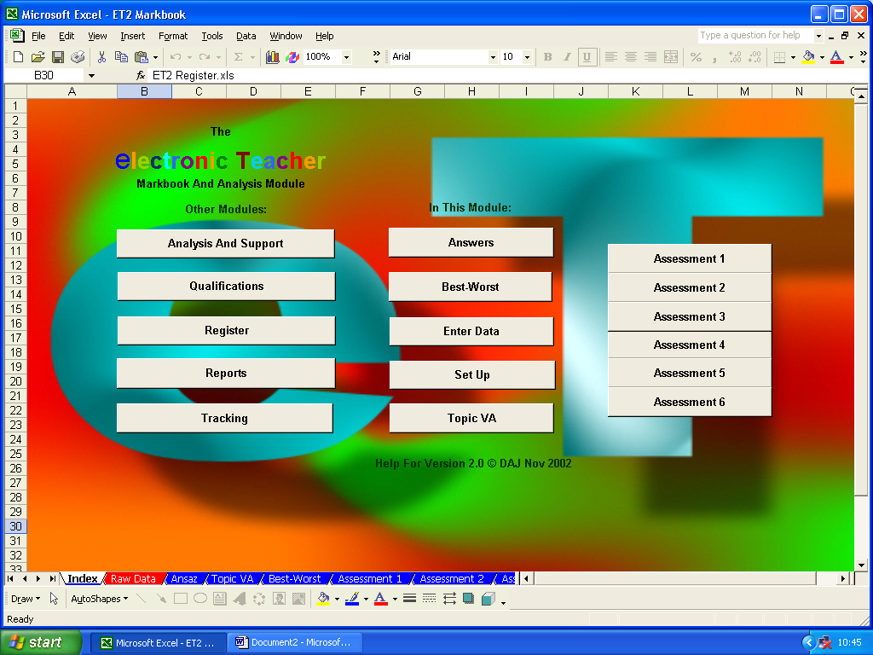

Go To Other Modules Go To Sheets Within The Current Module

Set Up

The Markbook Module is the heart of ET. This is where you define the types of assessment you wish to carry out and enter student details…these will then be automatically transferred to all the other modules…so open up the file ‘ET2 Markbook.xls’ and click on the ‘Set Up’ button.

The ‘Set Up’ sheet currently looks like this…

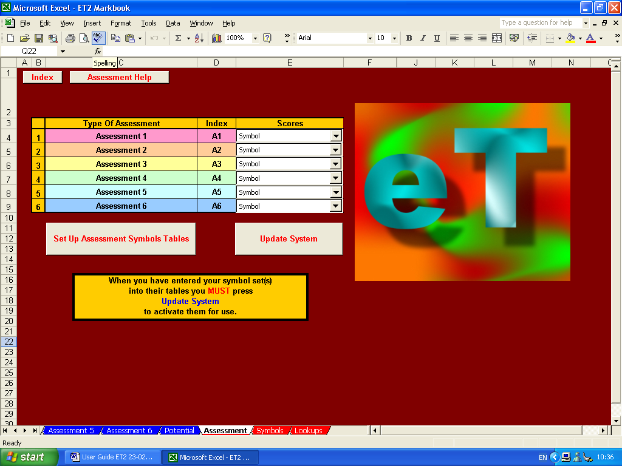

You can choose up to six different types of assessment - which types you use are entirely up to you but, generally, they will be from one of three main forms: Generic, Specific or Diverse.
Generic

Setting up your markbook for generic assessment might mean that you are interested in awarding scores for performance in terms of achievement and effort, as well as assessing behaviour, adherence to rules, etc.

To set up the markbook for this type of assessment, simply click in the cell containing ‘Assessment 1’ and replace this with the name of the first type assessment you wish to carry out. Repeat this for ‘Assessment 2’, etc. and remove the entries for any surplus assessments.

Here ‘Achievement’, ‘Effort’, ‘Behaviour’ and ‘Rules’ have been inserted and the last two surplus cells have been emptied.

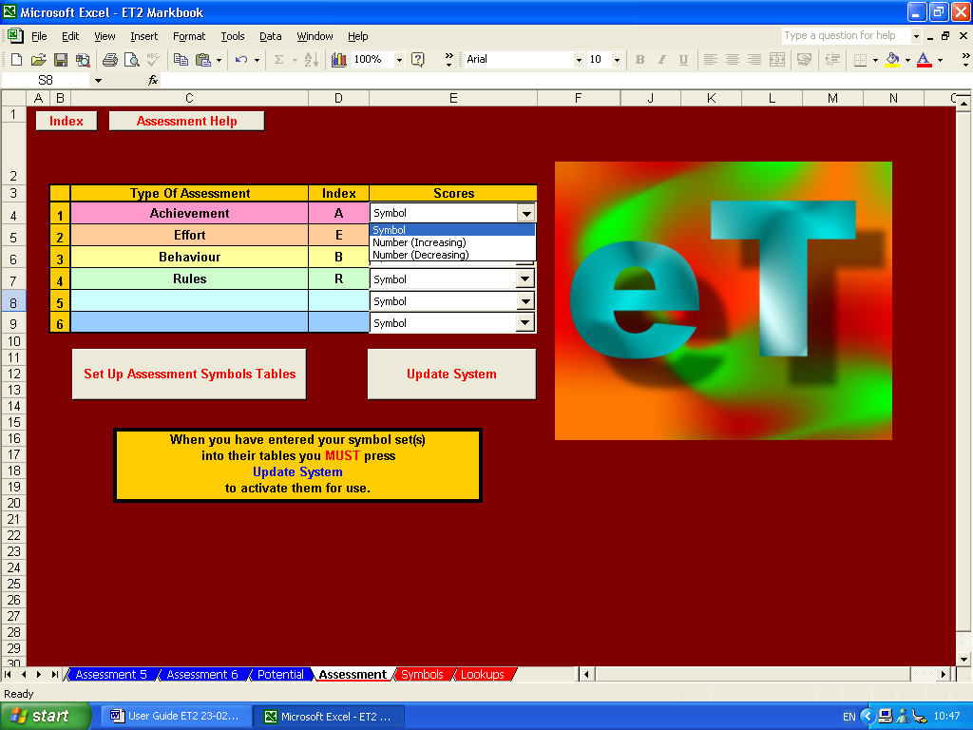

Next, assign an index for each type of assessment. Typically, this should be a single letter, a pair of letters (for instance, if two assessment types begin with the same letter), or some other small code that will be used throughout the markbook, not least to indicate which scores should be aggregated together. Here, the letter ‘A’ will be used to indicate which scores are ‘achievement’ scores. Similarly, ‘E’ for ‘effort’ scores, ‘B’ for ‘behaviour’ scores and ‘R’ for ‘rules’ scores. Surplus indices have been removed.

Now choose what type of score you wish to use for each type of assessment. You have a choice of three main types of scoring system: Number (Increasing), Number (Decreasing) and Symbol.

Number (Increasing) is the most common numericalal scoring system and applies to situations, for instance, where a score of 12 out of 16 is better than a score of 11 out of 16.

Number (Decreasing) is less common but is applied to situations where a final score depends on making a minimum number of errors for a specified set of tasks…2 out of 8, therefore, being better than 3 out of 8, for example.

Symbol is the most versatile and user-definable scoring system and applies to all other types of scores…letter grades (A, B, C…), letter-plus grades (A+, A, A-, B+, B, B-, C+, C…), GCSE/GCE grades (A*, A, B, C…), national curriculum grades (1a, 1b, 1c, 2a, 2b, 2c…), static number grades (1, 2, 3…), etc., etc….

To set up your symbol set, click on the ‘Set Up Assessment Symbols Tables’ button.

As you can see, the tables already show the assessment type name and index at the top…so now simply add the symbol set you wish to use beneath these starting with the highest grade at the top of the column followed by the next highest grade, then the next, etc.…

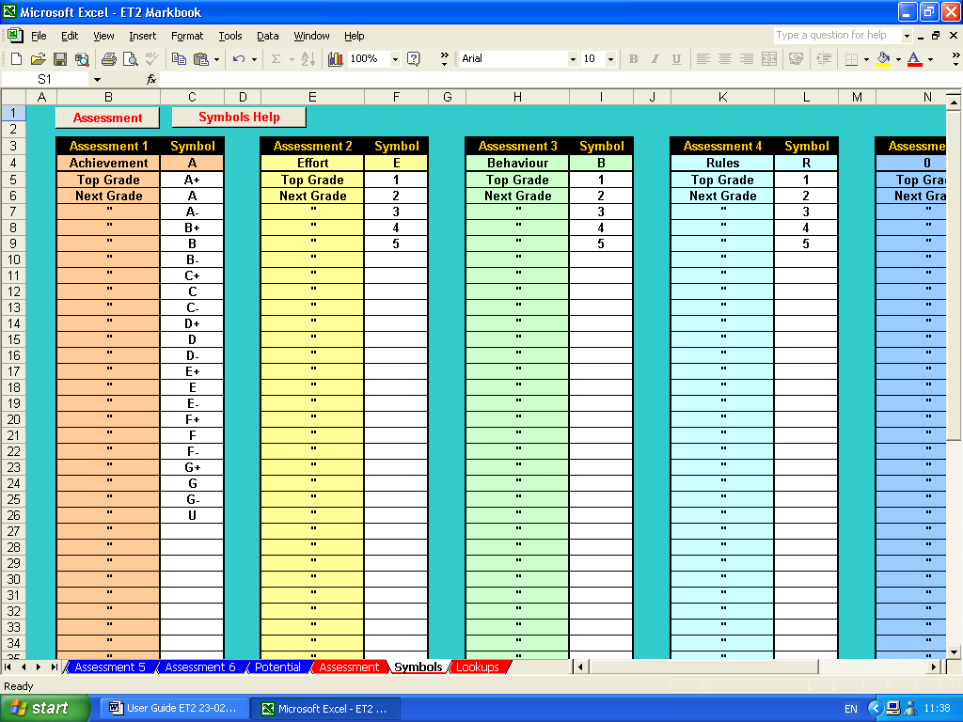

Here, some GCSE grades have been used for achievement scores and static numbers have been used for effort, behaviour and rules scores.

When you have entered all the required symbol sets return to the assessment set up sheet by clicking on the ‘Assessment’ button in the top left-hand corner.

Finally, you need to click on the ‘Update System’ button to allow ET to update the symbols and other set up details you have entered. Failure to do this may lead to erroneous scoring…so it is imperative not to forget this stage of the set up.

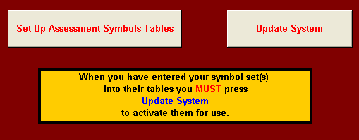

To return to the navigation sheet, click on the ‘Index’ button in the top left-hand corner.

Group Details

Having set up the type of assessment you wish to carry out, it is now time to enter the details of those students you wish to assess. To do this, click on the ‘Enter Data’ button.

The empty ‘Raw Data’ sheet should currently look like this…

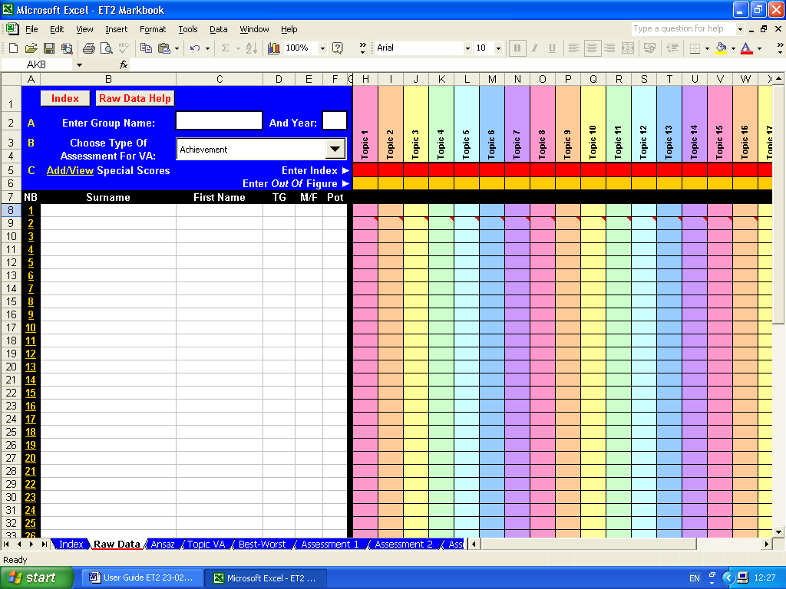

First, enter the name of the teaching group and their year in the relevant white cells.

Then add the details of the group members. For ET to work properly, you will have insert each group member’s surname, first name, tutor or teaching group (‘TG’), gender (‘M/F’) and some numerical indicator of each student’s potential (‘Pot’).

This ‘Pot’ indicator is needed to allow ET to perform its ‘value-added’ analysis.

For most students in primary and secondary phases, this is most likely to be the student’s most recent Cognitive Ability Test (CAT) score.

For 6th form students, you may wish to use an index such as an Advanced Level Information System (ALIS) score.

In fact, any objective numerical indicator of a student’s potential will work here…from an IQ score to any numerical equivalent of an anticipated GCSE, A-level, degree or other pass rate.

However, it is imperative that all members of the group have ‘Pot’ indicators, so where objective CAT scores, etc. may be missing, a considered estimate should be put in its place.

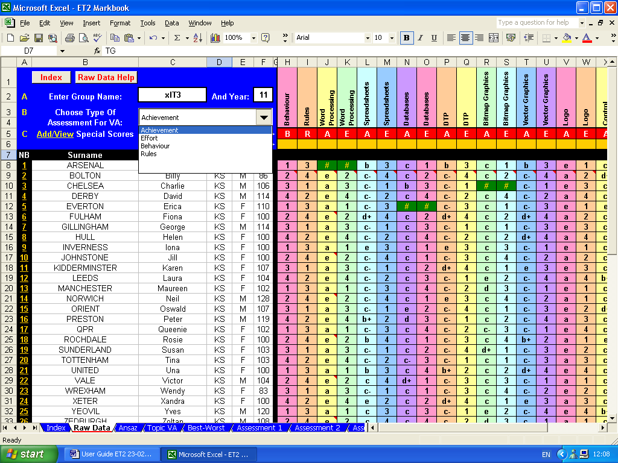

To select which assessment type will be used to calculate ‘value-added’ scores, simply click on the drop-down menu and choose the type required from the list. Here, ‘achievement has been selected.

Student details can be typed in from scratch, however, it is anticipated that, in most cases, the relevant details can be extracted from a school or college information system and then be copied and pasted into ET as appropriate.

ET’s markbook is now ready for day-to-day use.

Each time a new assessment is carried out the following details should be added to ET’s ‘Raw Data’ sheet:

- The name of the current topic or assessment type should be inserted in the top cell of each column;
- The assessment index should be inserted in the appropriate red cell to tell ET what type of assessment this is;
- If the assessment scores are numerical, the relevant ‘out of score’ should be inserted in the appropriate yellow cell
- Finally, individual student scores should be inserted in the relevant rows.

Here, ‘Behaviour’, ‘Rules’, ‘Word Processing’ achievement, ‘Word Processing’ effort, ‘Spreadsheet’ achievement, etc. have been added, together with their appropriate indices…’B’, ‘R’, ‘A’ and ‘E’…on the red row.

As none of the assessment scores in this example are numerical, no ‘out of scores’ have been inserted in the yellow row.

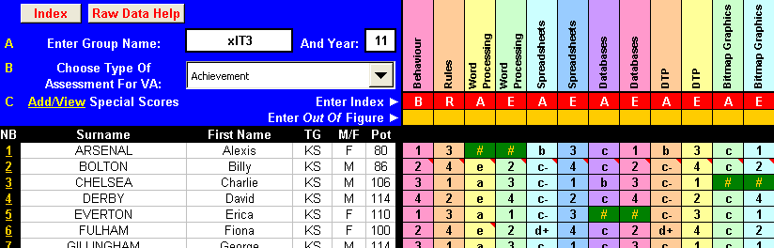

Relevant topic scores can now be added for each individual student. A ‘#’ symbol should be inserted if work is ‘not submitted’ for whatever reason.

Specific

Setting up your markbook for specific assessment might mean that you are interested in awarding scores for performance in terms of well-defined strands or topics. For instance, a secondary technology course may wish to assess student performance in terms of their ability at analysis, design, implementation, testing, evaluation and user documentation.

To set up the markbook for this type of assessment, as before, simply open the ‘Set Up’ sheet and click in the cell containing ‘Assessment 1’ and replace this with the name of the first type assessment you wish to carry out. Repeat this for ‘Assessment 2’, etc.

Appropriate indices should also be inserted and appropriate scoring systems should be selected.

Here assessment titles of ‘Analysis’, ‘Design’, ‘Implementation’, ‘Testing’, ‘Evaluation’ and ‘Documentation’ have been inserted as have appropriate indices of ‘A’, ‘De’, ‘I’, ‘T’, ‘E’ and ‘Do’.

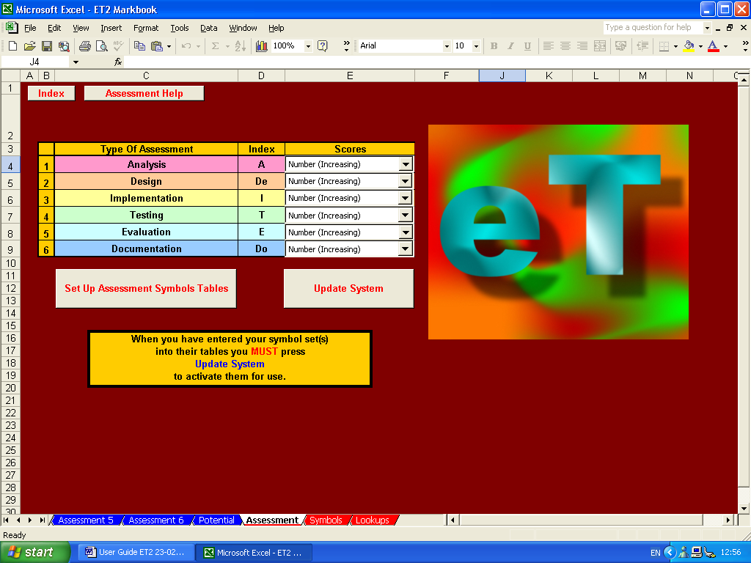

Increasing numbers have been chosen throughout as the scoring system and, as such, no symbol sets need to be defined.

Group and individual student details can now be added as above and a type of assessment can be designated for calculating value-added analysis. Here, implementation has been chosen for this task.

Again, topic titles and assessment titles should be inserted in the top cell of each column, assessment indices inserted in the red row, and ‘out of scores’ should be inserted, where appropriate in the yellow row. Here, ‘Table Lamp’, table lamp ‘Analysis’, table lamp ‘Design’, etc. have been added, together with their appropriate indices…’A’, ‘De’, ‘I’ and ‘E’, etc.…on the red row.

As the assessment scores in this example are numerical, relevant ‘out of scores’ have also been inserted in the yellow row.

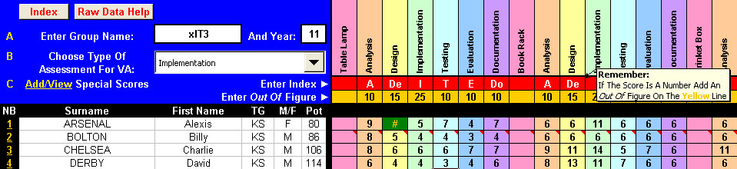

Relevant topic scores can now be added for each individual student and, as before, a ‘#’ symbol should be inserted if work is ‘not submitted’.
Diverse

ET can cope with a wide variety of assessment types and/or scoring systems and these can live happily together within any particular markbook.

Following the techniques detailed above, here is a markbook set up to accept numbers, letter grades, letter grades with + and – signs, national curriculum grades…even Greek, Arabic and exclamations!

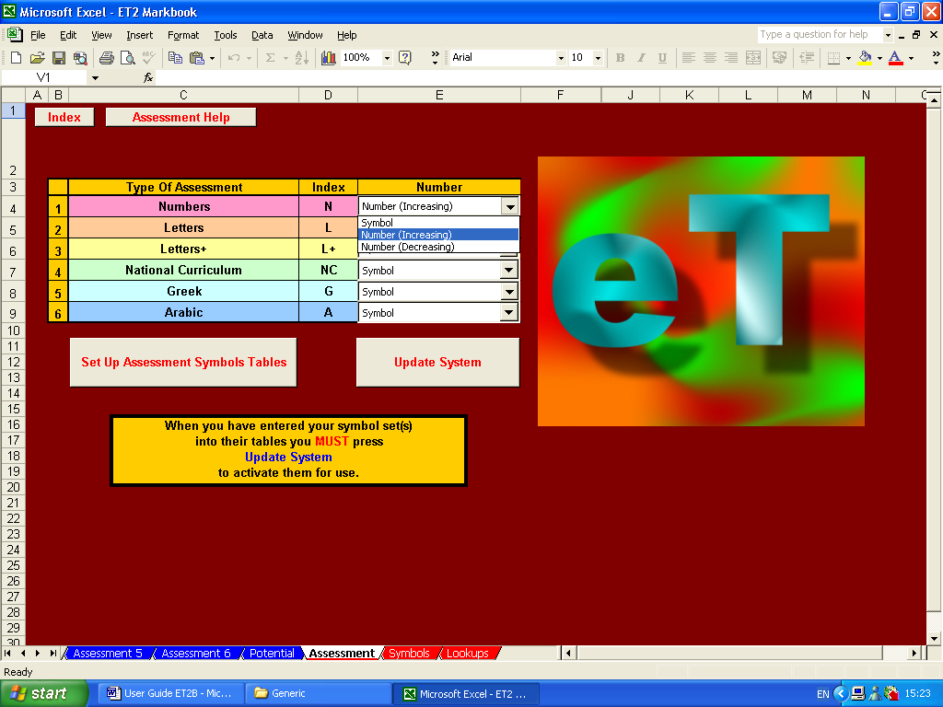

This is how the assessment symbols tables have been set up…again, highest grade at the top of the column, then the next highest grade, then the next, then the next…

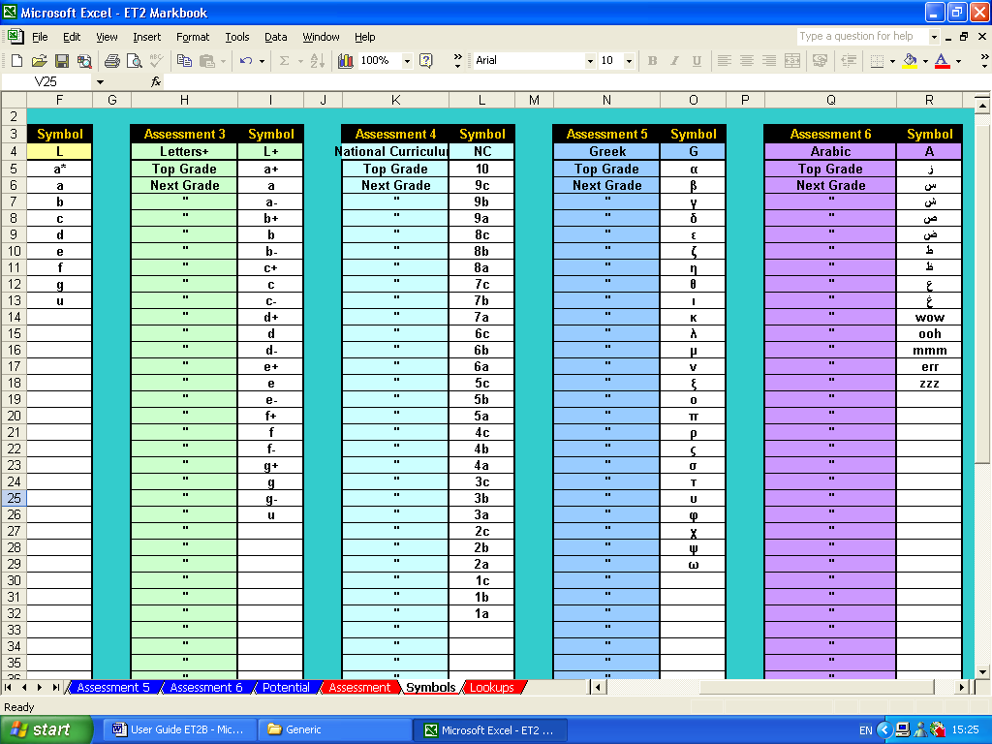

Remember that after the assessment symbol tables have been set up, you must press the ‘Update System’ button if ET is to work correctly.

After this, simply add group, student and topic details as above, together with assessment indices, ‘out of scores’ (where appropriate) and individual scores.

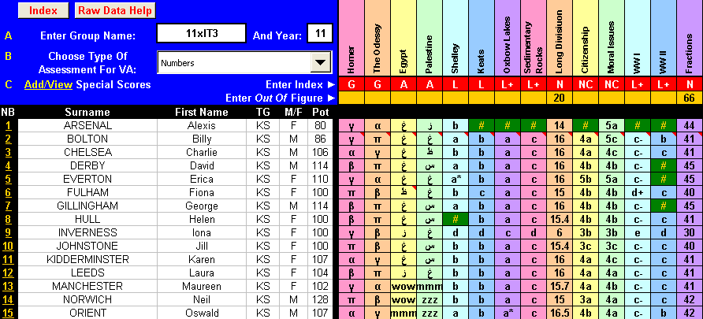

Primary

ET caters for one particularly diverse assessment situation – UK primary phase.

The national curriculum at primary level effective consists of four core subjects (Literacy, Numeracy, Science and IT) and eight foundation subjects (Art, Geography, History, MFL, Music, PE, PSHE and Technology).

ET’s primary modules split this workload into two easily manageable sections.

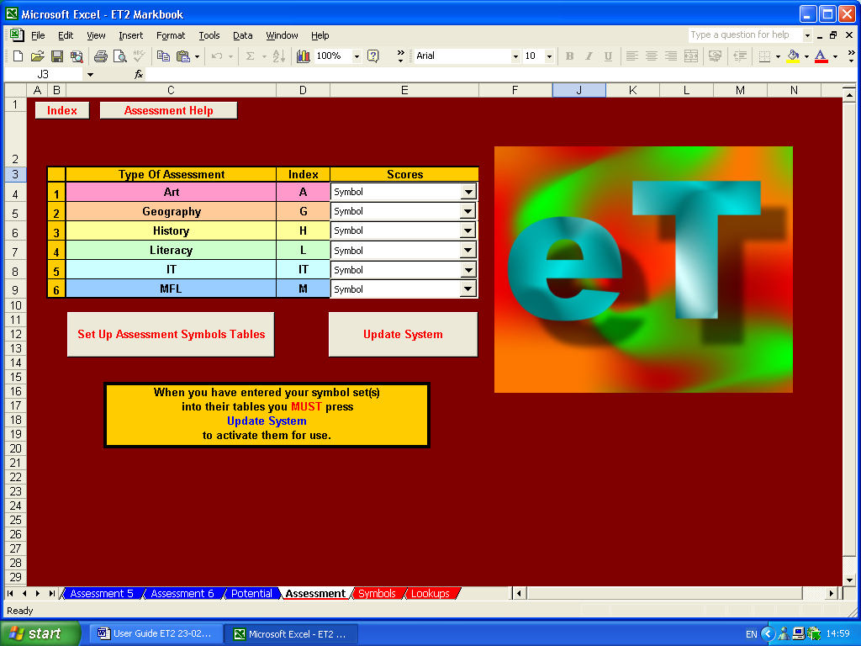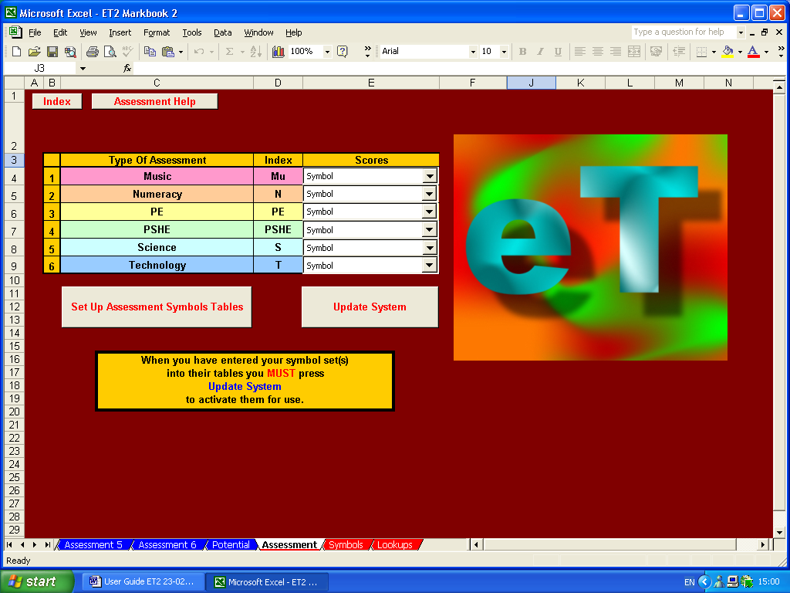

These have already been set up to identify national curriculum subjects as assessment types (Art, Geography, History, etc.); have been given appropriate assessment indices (‘A’, ‘G’, ‘H’, etc.); and appropriate symbol tables to accept national curriculum grades (1a, 1b, 1c, 2a, etc.)
If you wish to use ET’s primary modules, all that remains is for you enter group and individual student details and choose the type of assessment to be designated for calculating value-added analysis. Here, this is Mrs Smith’s Year 5 group and literacy has been chosen as the assessment to be used for value-added calculations.

Again, topic titles should be inserted in the top cell of each column, assessment indices inserted in the red row. Here, ‘Portrait’, ‘Seaside Study’, etc. have been added, together with their appropriate indices…’A’, ‘G’, etc.

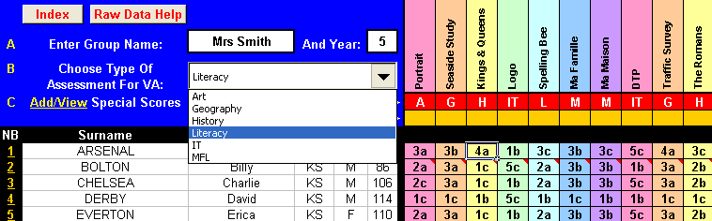

That should be it…finished! Your markbook, whatever its precise type and contents, should now be set up.

If nothing else, ET has already provided an easily manageable, high quality, electronic method of recording your assessment of students and it might well be worth using ET solely for this purpose. However, ET does much more than this…and here is where ET more than repays your efforts to date and starts to earn its corn….

Formative And Performance Analysis

Click on the ‘Index’ button in the top left-hand corner and return to ET’s main navigation sheet. Now click on the ‘Answers’ button.

Answers

For the purposes of this demonstration, let’s look at the ‘Answers’ sheet for the general, diverse markbook…it will show examples that apply to all the other types of markbook assessment.

First, note that ET has transferred all the group and individual student details needed for this sheet from the raw data sheet. It has also transferred all topic titles, assessment indices, individual symbol scores and ‘not submitted’ (‘#’) marks.

Where numerical scores have been used in the raw data sheet, these have been automatically converted to percentage scores.

This is why including an ‘out of score’ on the yellow row of the raw data sheet is so important…without it an individual number score of, say, 10 is meaningless – 10 ‘out of’ 10 (100%) is impressive, 10 ‘out of’ 100 (10%) not quite so…ET needs it to work out the answer!

ET automatically calculates the group average score for each topic, regardless of whether numbers (increasing or decreasing) or symbols have been used, and this is shown in the black row at the top of each column. This should give an indication of how well this particularly topic was received.

For instance, if the average score is very low, it may be worthwhile considering how this topic might better be delivered in future or what additional resources could be employed at present. If the scores are very high, it may be worthwhile considering using more challenging material.

ET also automatically calculates the individual averages for all the assessment types that have been set up. Here, individual number (‘N’), letter (‘L’), letter+ (‘L+’), national curriculum (‘NC’), Greek (‘G’) and Arabic (‘A’) averages have been calculated and are shown in the black area to the right of the individual student details. The group averages are once more shown on the black row at the top of these columns.

Where letter or letter+ scores have been used, ET automatically highlights C-D borderline average scores in green. This can be used, in the context of GCSE groups for instance, to easily identify students who might significantly benefit from additional attention.

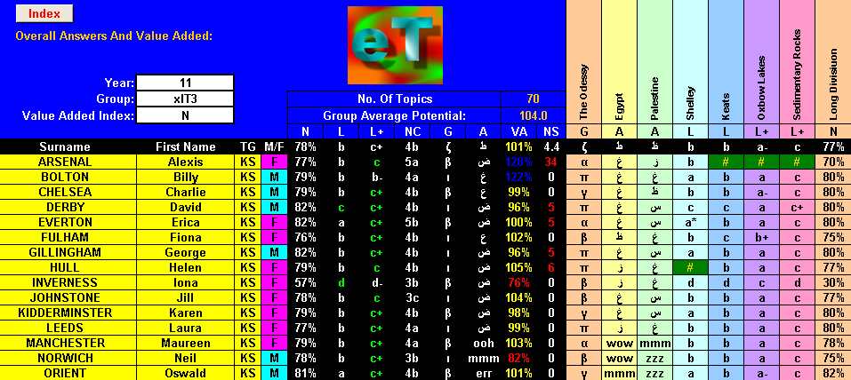

In addition to this, ET calculates the average individual value-added (VA) scores. If a student is performing exactly in-line with expectations they should have a VA score of 100%. VA scores within 10% of this are shown in yellow. Students who are performing more than 10% above expectations are shown in blue, those more than 10% below expectations in red.

Again, ET enables the easy identification of students with exceptional performances, allowing praise or additional attention to be focussed appropriately and effectively

Finally, ET adds up the number of pieces of work that were ‘not submitted’ and where this comes to five or more, these totals are also shown in red…once again, easily highlighting a significant problem so it can be addressed.

If you wish to look at each assessment type individually, return to the main navigation sheet and click on the relevant button…’Assessment 1’ to ‘Assessment 6’.

If, in this example, there is a need to look at, say, the Arabic marks, click on ‘Assessment 6’ and you will be taken to a sheet which only shows details of those topics marked in Arabic.

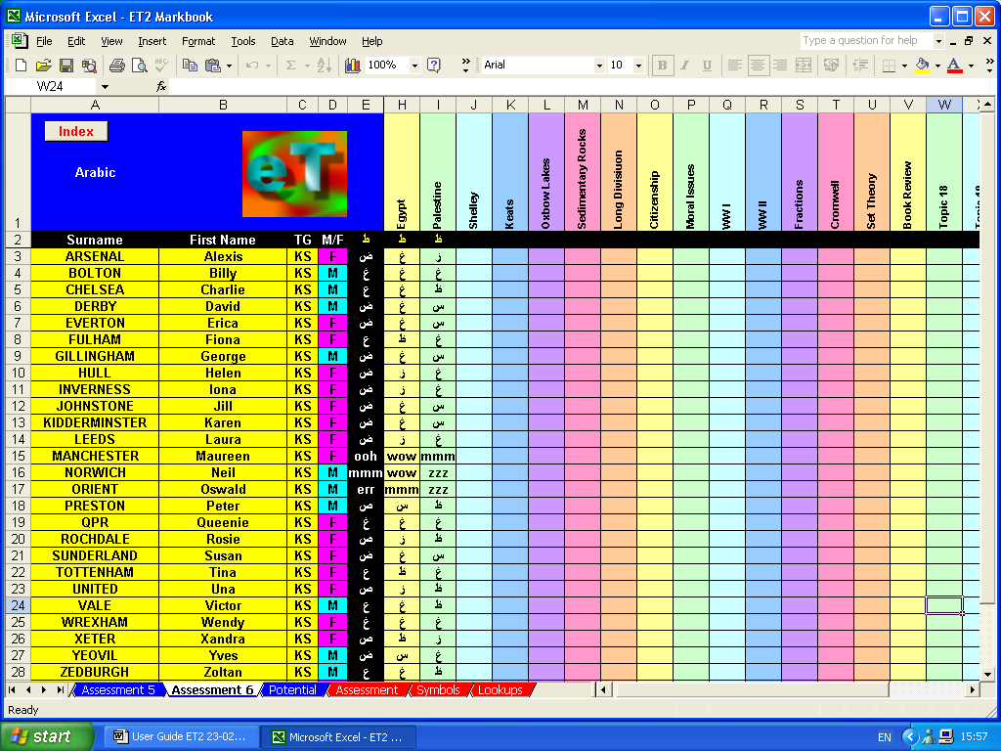

Topic-By-Topic Value-Added

ET’s ability to calculate overall VA scores for each individual student is an extremely valuable tool but, to allow for more formative assessment to take place, it may be still more valuable to calculate value-added on a topic-by-topic basis.

ET does this, again, highlighting scores of more than 110% in blue and less than 90% in red…allowing exceptional performances to be identified and then praised or remedied immediately.

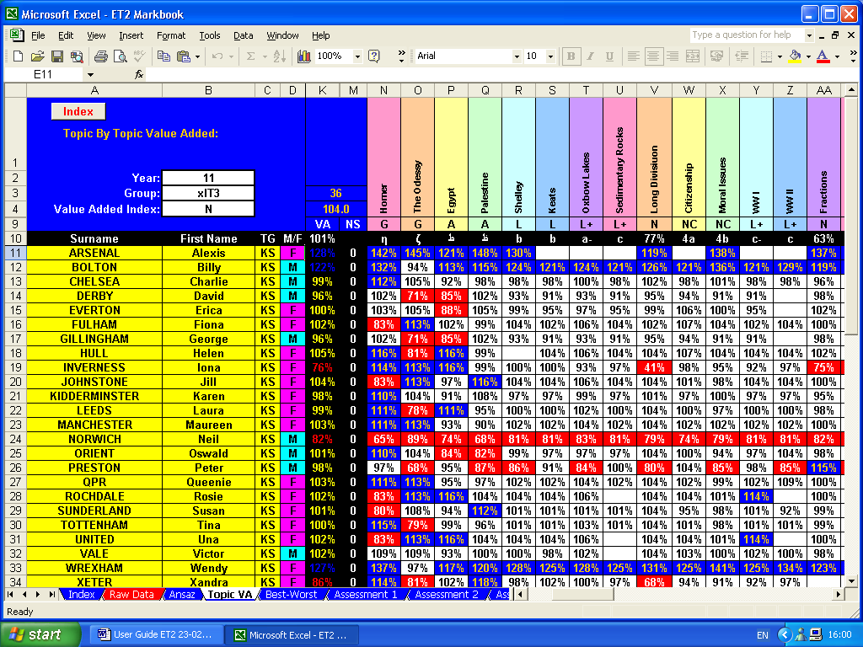
Best-Worst

ET’s ‘Best-Worst’ sheet uses the topic-by-topic VA scores to identify the title of the topics which resulted in the best and worst performances.

Provided informative titles are used to identify topics, these can help in providing a formative assessment of performance.

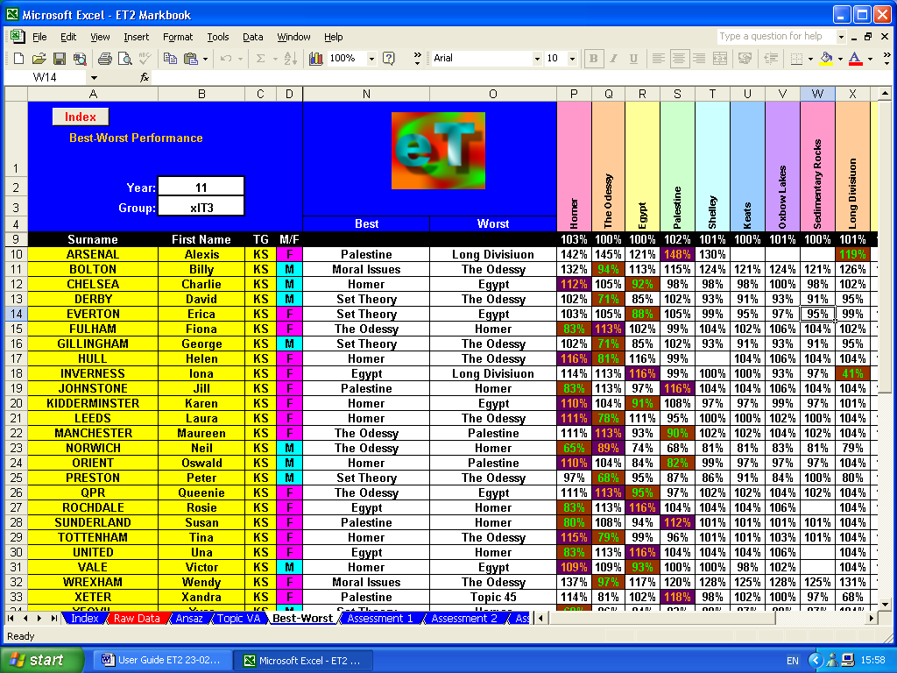

Individual Results

The ‘Individual Results’ sheet displays the average results for each assessment type, together with ‘Best-Worst’ and other data. It also displays VA scores for all topics both in tabular and graphic forms. To select any given student, click on the drop-down menu button and choose the appropriate surname. Alternatively, type in the student’s group number…this can be found in the ‘NB’ column of the ‘Raw Data’ sheet.

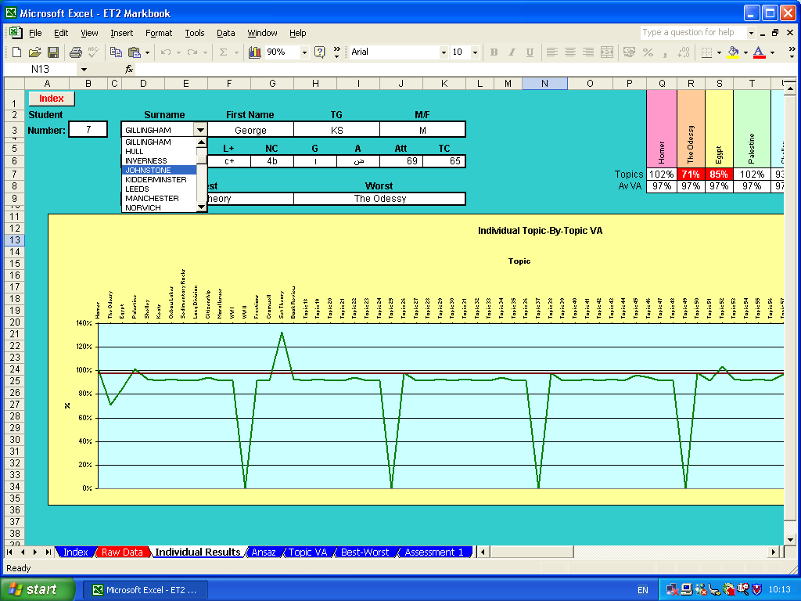

Analysis And Support Module

The navigation sheet for the analysis and support module looks like this and contains navigation buttons to three additional facilities.

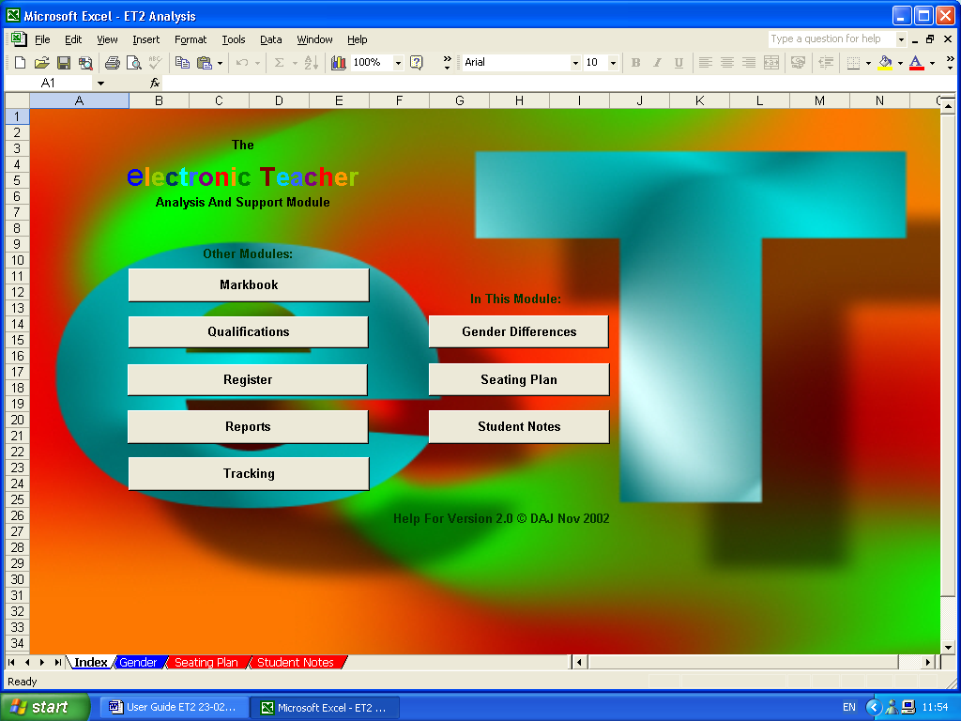

Gender Analysis

The gender analysis section automatically produces the following display. The first two tables at the bottom display gender specific averages for each of the assessment types defined in the main markbook, together with average VA and ‘not submitted’ (NS) scores.

The third table displays gender differences, male performance relative to female…identical performance levels being indicated by a value of 100%. If male performance exceeds female performance scores will be higher than 100%, if female exceed male scores are less than 100%. If scores are larger than 110% or smaller than 90%, they are automatically highlighted blue or red, respectively.

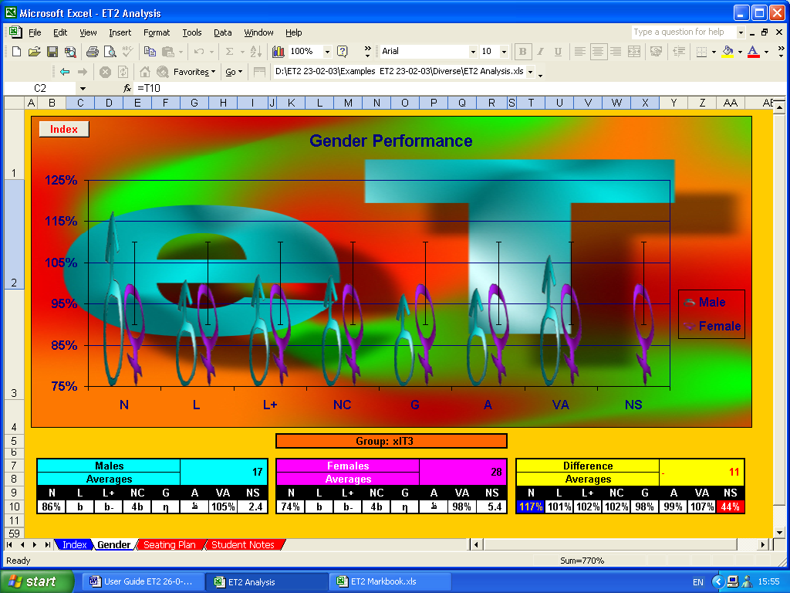

The graphics above give a visual representation of these relative performance figures. Female performance is always indicated as 100% and male performance is shown relative to this. The vertical green bars indicate the +10% and -10% boundaries.

Clearly, ET cannot do this analysis accurately unless ‘M’/’F’ gender indicators are provided in the main markbook.

Seating Plan

One way of tackling differences in gender performance in mixed gender teaching groups is to try to alter the social and working dynamics of the group by splitting up male and female groupings.

This can be done easily in most teaching environments by simply allocating seats boy-girl-boy-girl or girl-boy-girl-boy, depending on which gender comes first alphabetically.

ET’s seating plan sheet can do this for you automatically, if required, placing students alternative by gender, starting with the first name in the markbook, until all the members of one gender have been allocated seats. The remaining members of the opposite gender are then added en bloc at the end.

To do this press the ‘Auto Seating Plan’ button…ET displays the seating order on screen for 30 seconds before reverting to alphabetical-gender order.

ET also displays VA scores…again, exceptionally good scores being shown in blue, poor scores in red.

This can provide an extremely powerful tool as it allows for a visual VA analysis by position…showing where clusters of exceptionally performing students, if any, are positioned and allowing these grouping to be broken up, more evenly distributed or tackled by other means.

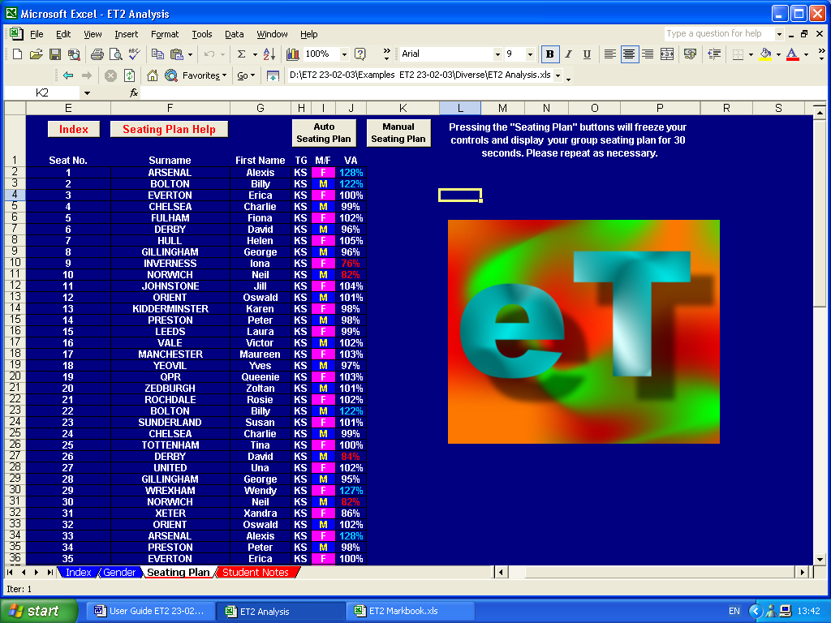

To assist in repositioning students, ET allows for manual override of the seat allocating system. To do this, simply swap the seat number of one student with that of another by typing the relevant numbers in the relevant cells and then press the ‘Manual Seating Plan’ button.

These positions will remain as currently set until either a new ‘auto seating plan’ is requested or until further seating swaps are carried out followed by the pressing the ‘manual seating plan’ button…so changes in performance subsequent to re-seating can be monitored.

Student Notes

There are often situations were it may be beneficial to have additional notes about certain students easily at hand.

For instance, it may be useful to have brief details about students with special needs, a noteworthy medical condition, or, where a particular subject is taught as a ‘circus’ such as in, say, a technology department where one teacher may deliver food technology, another graphics, another resistant materials, etc., etc.

ET’s ‘Student Notes’ sheet provides such a facility.

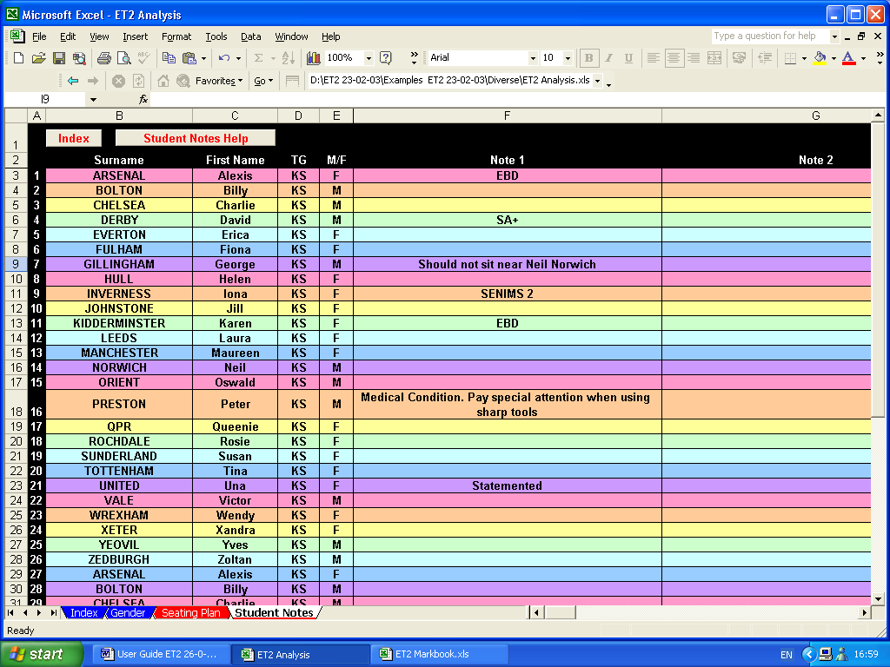

Register Module

The Register Module provides some of the more simple and straightforward of ET’s facilities.

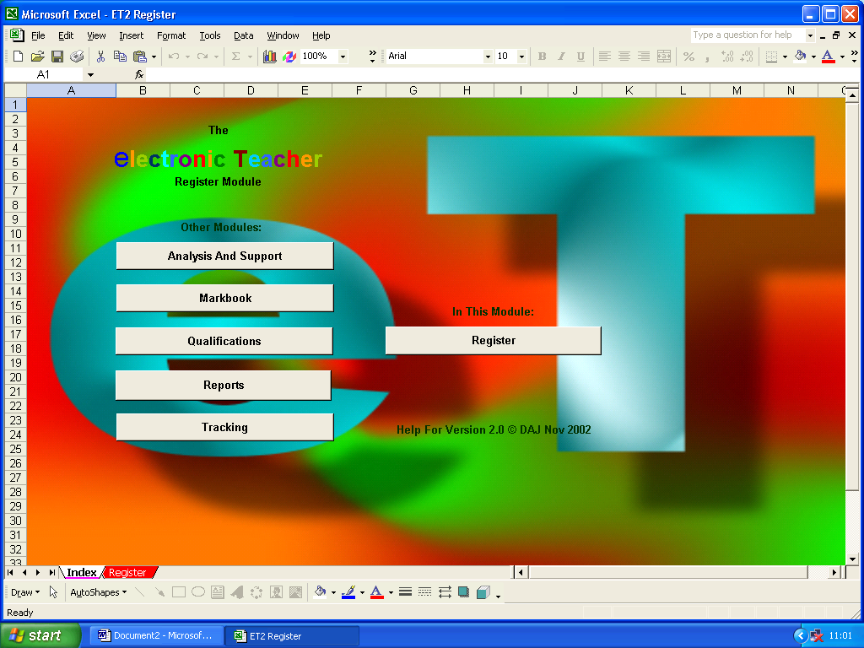

As ever, student details are automatically transferred from the main Markbook Module.

Attendance dates can be added at the top of each column and students are shown as being present by inserting a ‘1’, absent by inserting a ‘0’ and late by inserting a ‘#’.

The module automatically and immediately calculates the number of absences, the percentage attendance rate and the number of lates, indicating poor attendance rates and high late counts in red.

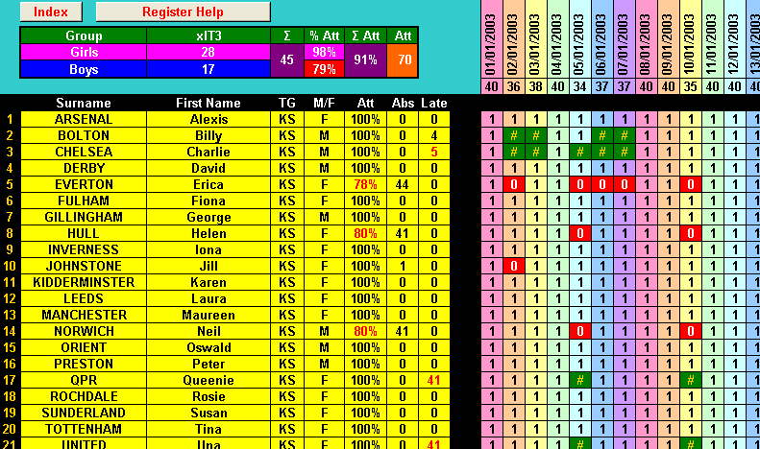

The module also calculates student numbers and attendance rates, both overall and by gender, as well as the total number of possible attendances. Again, significantly poor attendance rates by gender are highlighted in red.

Progress Tracking Module

The Tracking Module allows for setting, recording and monitoring of student performance relative to pre-set targets.

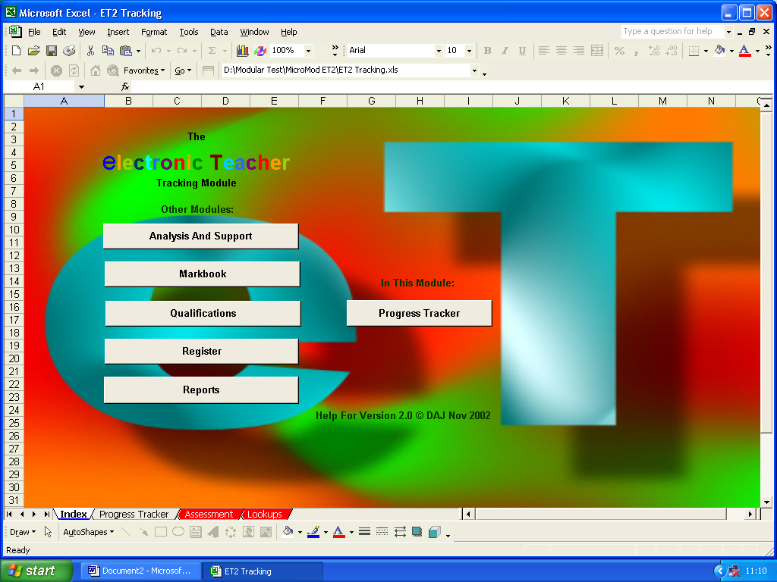

As ever, student details are populated from the main Markbook Module.

To start setting up the Progress Tracking Module, an assessment index should be entered. This can be any of the assessment indices defined in the Markbook Module.

Once the index is specified, appropriate level indicators for that index can be inserted for individual initial and target performance targets.

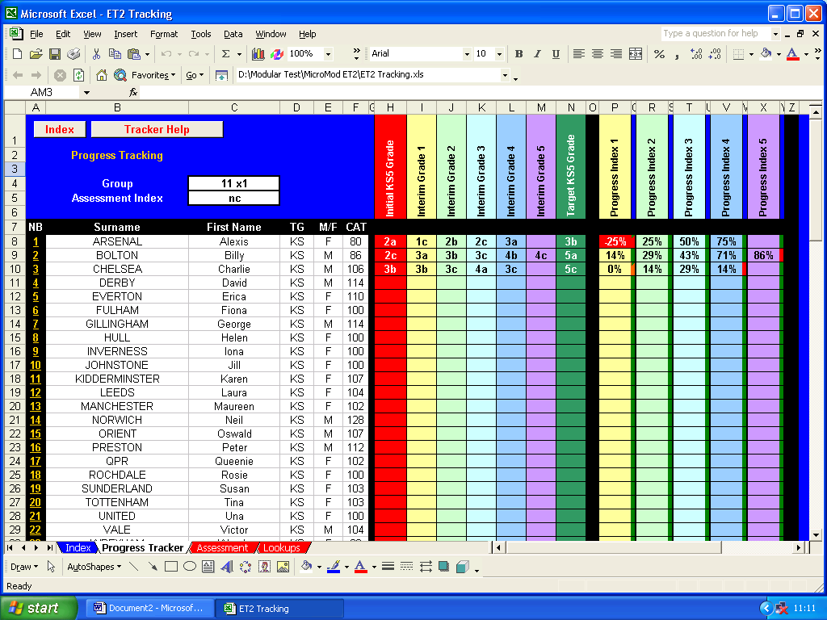

At relevant intervals, interim grades can be inserted.

The module outputs a percentage indicator of progress. Should an interim grade fall below the minimum target grade, this percentage is indicated in red.

As well as the percentage progress scores, a set of ‘traffic light’ indicators show whether the student has made progress from one interim grade to the next…green for ‘progress made’, amber for ‘no progress made’, and red for ‘performance worse’.

Qualification Module

The main Markbook Module is perfect for ‘normal’ use where monitoring the average performance of students is required.

However, in certain circumstances such as producing coursework for an official exam board qualification, what is required is the cumulative scores of students rather than their average scores.

The Qualification Module has been created to support you in this.

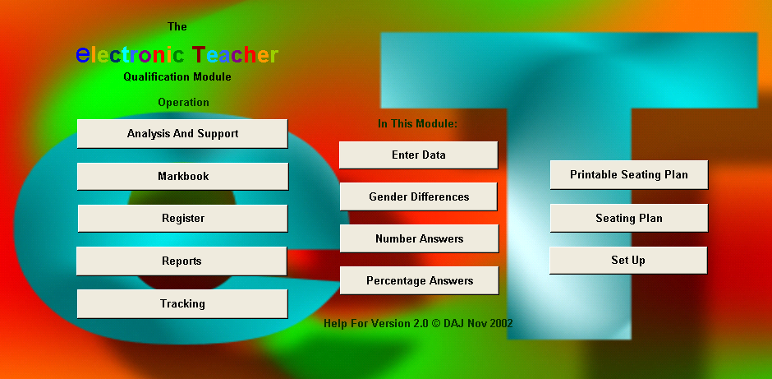

As for the main Markbook Module, the Qualification Module first needs to be setup by entering the names for the examination or coursework components, a short-hand index for each of the components, the percentage of the total possible that each component represents, and the total marks possible for each of the components.

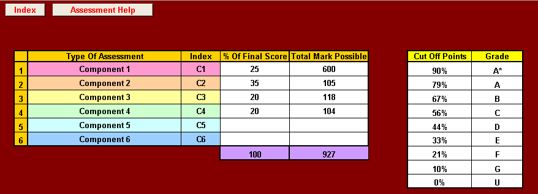

Percentage cut-off points and grade levels then need to be added.

As ever, student details are populated from the main Markbook Module. Each exam and/or coursework title, component index and individual scores can then be entered.

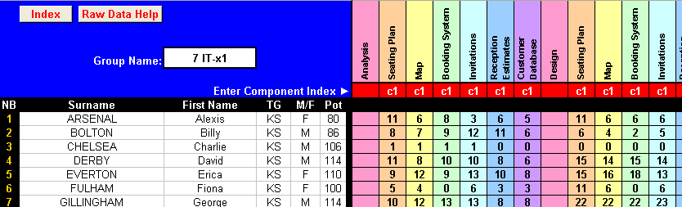

The module automatically and immediately calculates the cumulative percentage scores overall and for each of the components. It also calculates the grades relevant to each of these percentage scores. C/D borderline scores are shown in green.

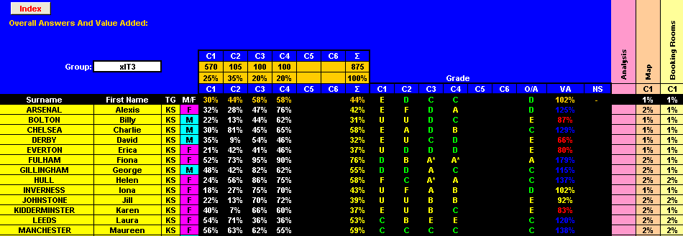

The module also works out individual value added scores indicating exceptional scores in red and blue.

To aid filling in exam board forms, the module also calculates individual component and overall cumulative raw scores.

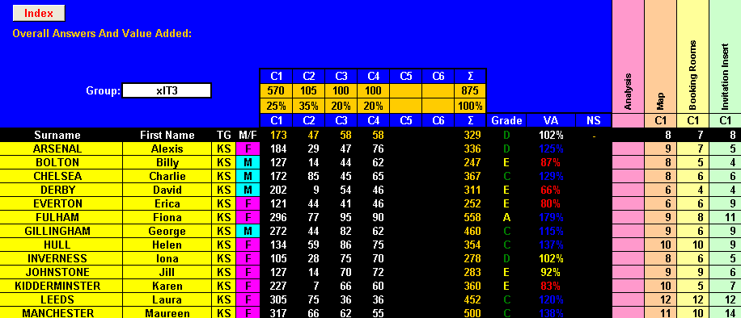

The module also comes with its own gender analysis, seating plan and printable seating plan sheets.

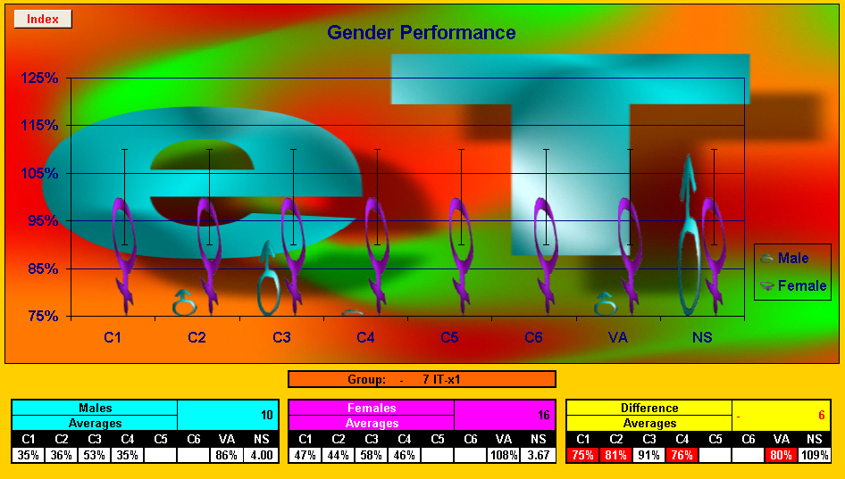

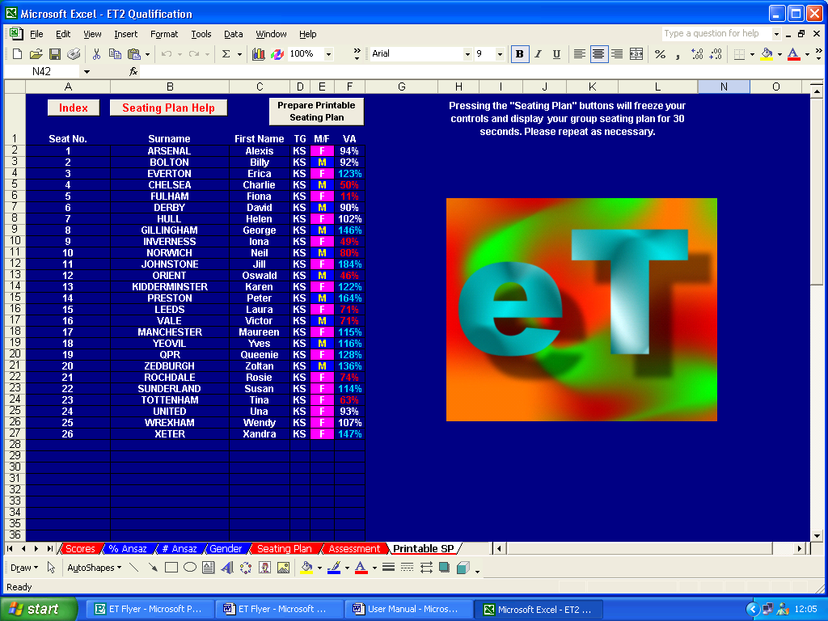

Report Module

ET’s Report Module is probably its most powerful in terms of workload reduction potential.

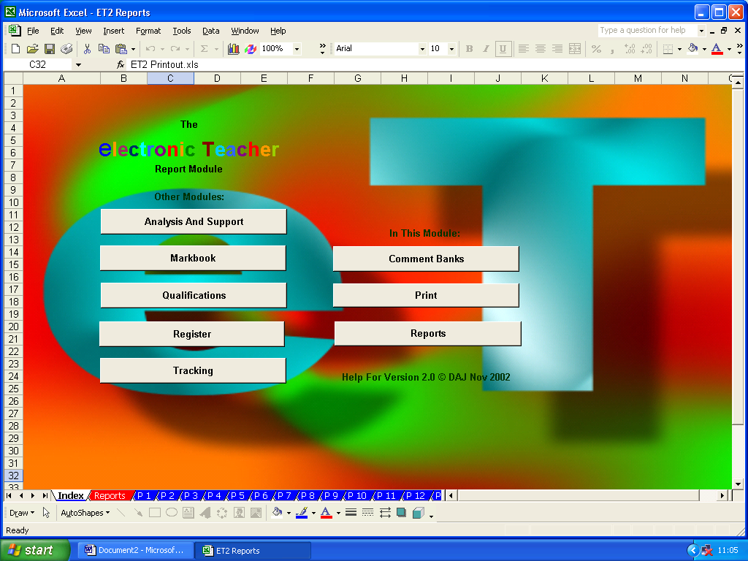

As ever, the first stage with the Report Module is to set it up…first the comment banks. These can be accessed from the comments navigation sheet.

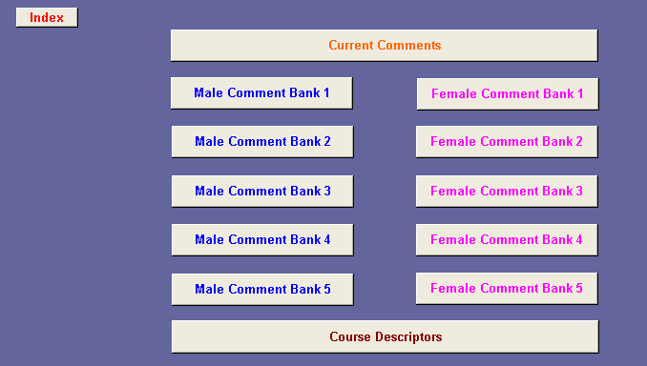

The module can contain up to five sets of course descriptions. These are intended to be short and succinct descriptions of the part of the course to which the current set of reports correspond. The descriptors are simply typed into relevant descriptor cell.

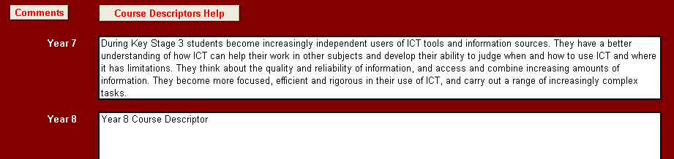
To ensure comprehensive and consistent comments are used for each student, the comment banks can contain up to 15 sub-sections. Each sub-section’s title should be entered in the table at the top of the comment bank. On entry these are then shown next to the individual comments for that sub-section.

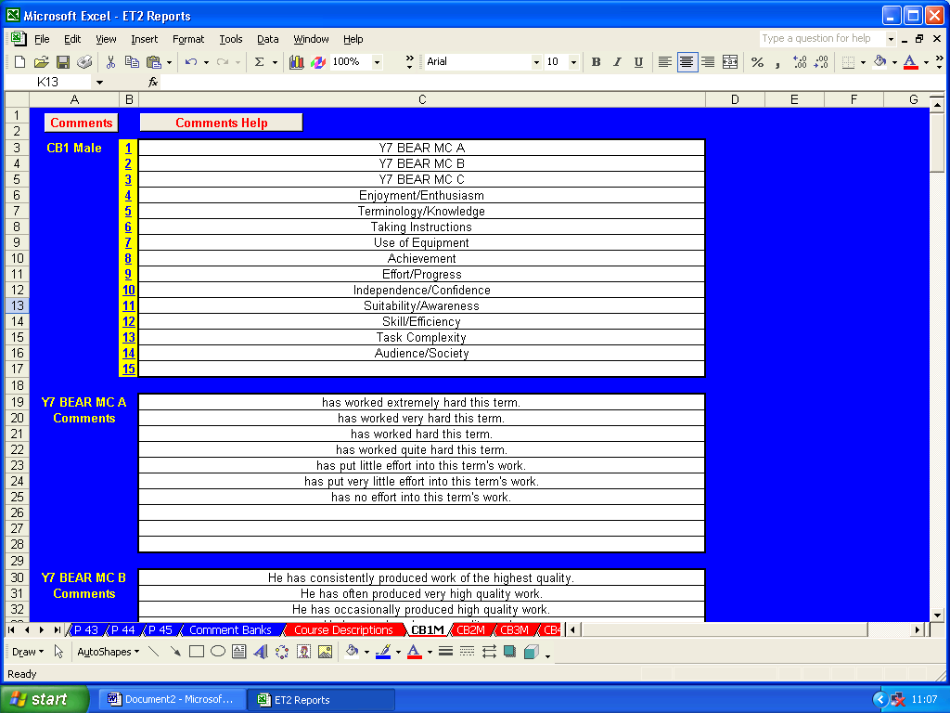

Up to 10 individual comments can be entered for each sub-section by typing them into the relevant cells. Two sets of comments need to be created, one for male students and one female. These can be created so they can be used with individual student’s name or using subject, object or possessive pronouns.

Individual comments can be created as whole, stand alone sentences.

Alternatively, comments can be created by combining front end, middle and/or back end sentence sections. Here, an example of a set of female comment starts with alternative and contrasting comment ends.

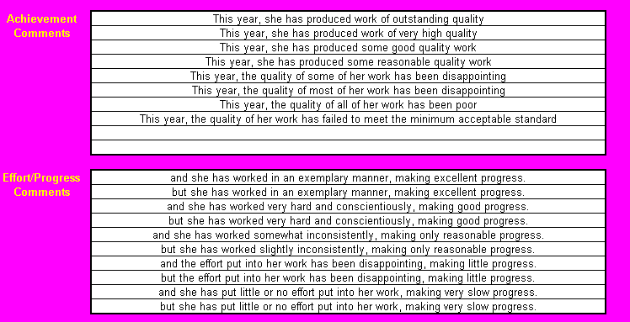

On completion, the whole set of comment sub-sections and male and female comments or comments sections can be seen on the Current Comments sheet.

Navigation to individual sub-sections can be facilitated by clicking on the numbered hyperlinks next to each sub-section title.

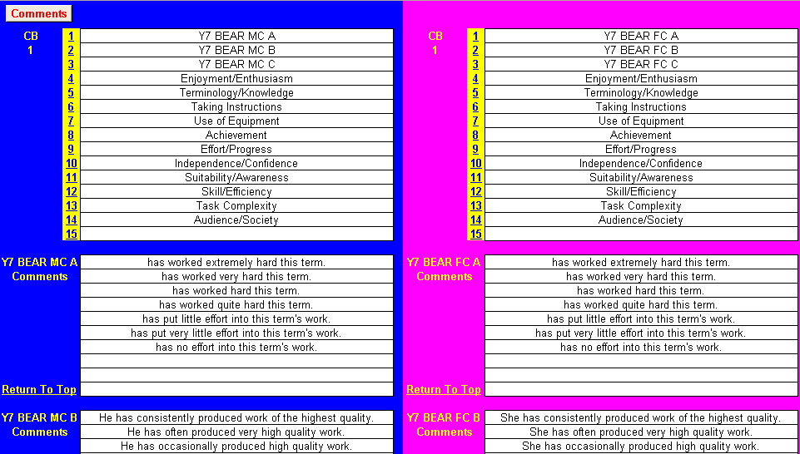
As ever, student details on the main report sheet are populated from the main markbook.

To complete the setup, add the date of issue, staff name and subject title and, finally, enter the number of the comment bank to be used.

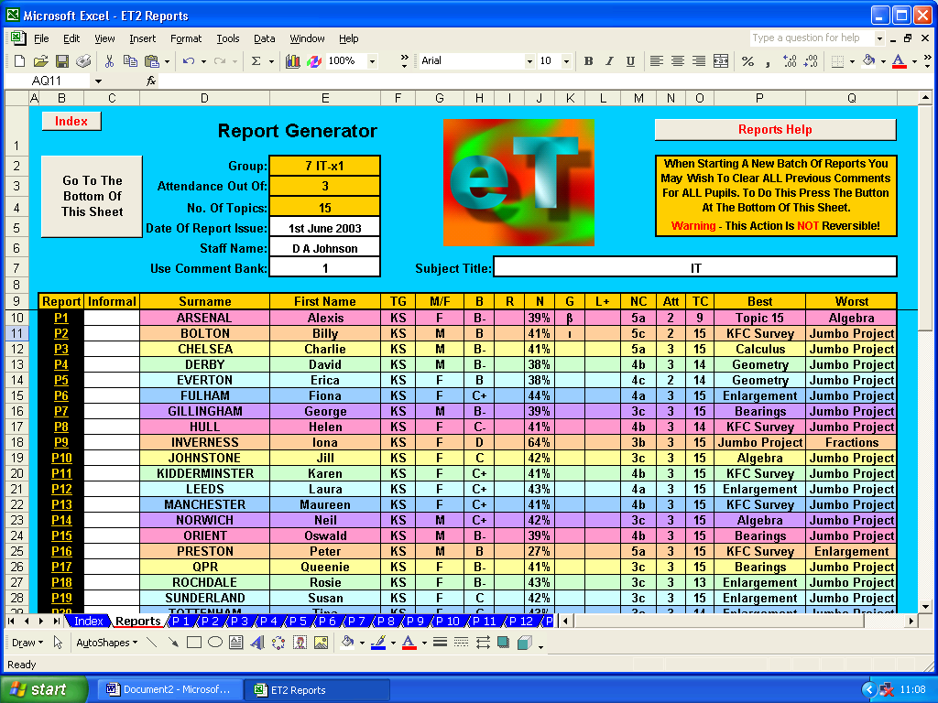

Should you wish to use informal names in the body of your reports, these can be added at this point.

If this is your first set of reports, the report generator will obviously be clear. However, if it has already been used to create a set of reports, you may wish to bulk clear previous comments. To do this, follow the instructions and note the warnings on screen…

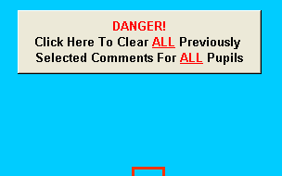

The set up is now complete…let’s move on to creating individual reports for individual students. Move to the report for an individual student by clicking on the appropriate “P1”, “P2”, etc. hyperlink in the leftmost column for that student.

The individual report sheet tries to help report creation.

Sub-section titles and gender sensitive comments are automatically displayed.

Individual student details are automatically displayed on the report generator including name, tutor/teaching group, assessment averages, work completed and attendance.

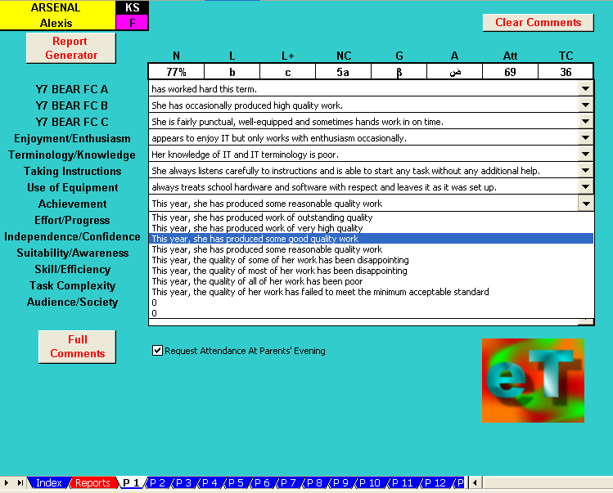

Comments for each sub-section are available on drop-down menus and can be selected merely by clicking on them.

Mail merge templates can be created from scratch for different types of report. Alternatively, those provided with ET can be used or amended.

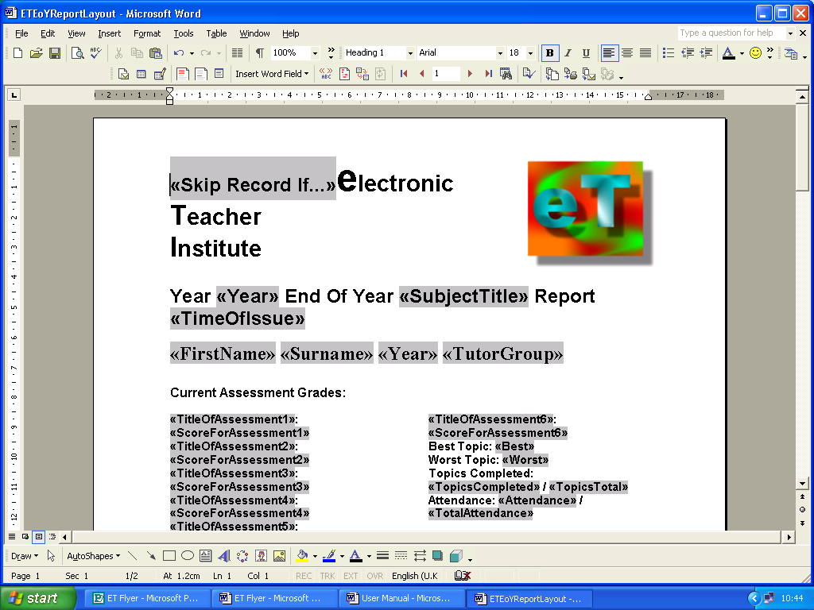
The templates included with ET not only insert the comments but will also insert the comment category titles.

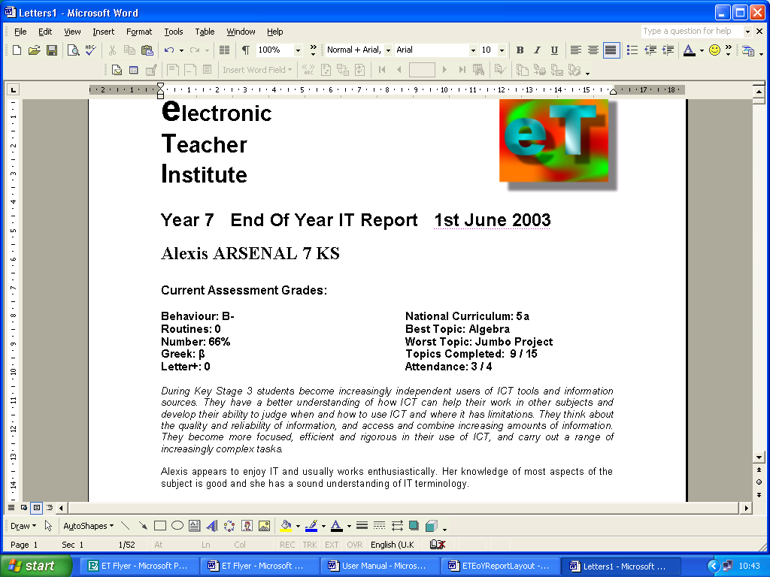

It will even produce a copy automatically…

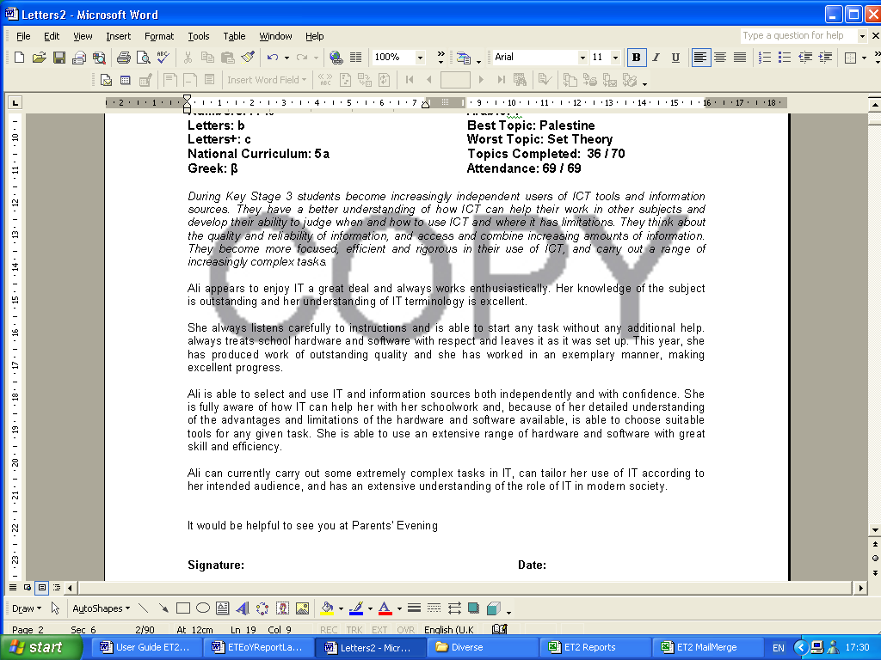

Ultimately, ET produces high-quality, individualised, comprehensive reports that, if required, can be amended or can even re-written from scratch…however, as student details and scores are automatically inserted, this still constitutes a considerable reduction in workload.

System Security

ET has been designed so that password protection should only allow data entry where data entry is anticipated. Should you wish to make any changes to ET the password is etph (ET phone home!). However, please seek in-school technical assistance before attempting this.

A set up generic markbook is included in the examples folder on the CD.
Rules = wearing correct uniform, bringing right equipment, etc.
ET automatically converts raw number scores (increasing and decreasing) into percentage scores…12 out of 16 thus being converted to 75%.
Symbols which should not be used are ‘#’ which ET’s markbook uses for work ‘not submitted’ and ET’s register uses for a student being late; ‘*’ and ‘?’ which are Excel wildcards; and apostrophes which Excel uses to indicate cell contents should be treated as verbatim.
Static number grades are numbers used as though they were symbols. For instance, one particular piece of work might be allocated an achievement grade of ‘A’ and an effort grade of ‘1’, another ‘A’ ‘2’, a third ‘B’ ‘2’, a fourth ‘B’ ‘1’, etc. In this case, ET’s would return a rounded up average effort grade of ‘1’…not 1.5 or 150%.
ET calculates ‘value-added’ scores very simply by comparing individual performance with group average performance, individual ‘Pot’ score with group average ‘Pot’ score and then comparing the two results: (individual performance ÷ group average performance) ÷ (individual ‘Pot’ score ÷ group average ‘Pot’ score) The theory being that a student with, say, a high CAT score should be expected to perform better relative to one with an average CAT sore. If their performance relative to the group average performance matches their potential relative to the group’s average potential, the above formula should give a value of 1 (100%). If their performance exceeds their potential, the formula will give a score of over 100%, if their performance falls short of their potential, it will give a score of under 100%.
Such as Capita’s Schools Information Management System (SIMS)
As this example uses ‘static numbers’, the numbers in it are treated merely as symbols and, therefore, do not require an ‘out of score’.
Be that, a student has not completed the work, a student was not present when the work was set, or whatever.
A set up specific markbook is included in the examples folder on the CD.
A set up diverse markbook is included in the examples folder on the CD.
Both blank and set up primary markbooks are included on the CD.
Note that this can be changed at any time if identifying value-added on a subject-by-subject basis is required.
This is included on the CD.
Clearly, if, for instance, ET is used with a maths group, it is not going to be informative to identify a best topic as ‘Chapter 7, Exercise 2, Questions 1-9’…however, it may be informative to identify the best topic as ‘Solving Equations’.
A facility for creating printable seating plans is included in the ‘Qualifications’ module.
E.g. ‘A’ for Achievement, ‘E’ for ‘Effort, or ‘NC’ for National Curriculum level.
Including mock exam scores, etc.
Enough for any UK school Key Stage or degree course.
If more than ten comments are needed for a particular section, two or more sub-sections blocks can be used.
He, him, his…she, her, her.
These can be used for reference if comments or sections are too large to fit in individual report genitors drop-down menus. See later.
“Chris” instead of “Christopher”, for instance.

