Markbook Module

Getting Started

Each module of ET opens with an ‘Index’ navigation sheet. The navigation buttons on the left of the sheet will take you to other modules. Those on the right will take you to sheets within the current module.

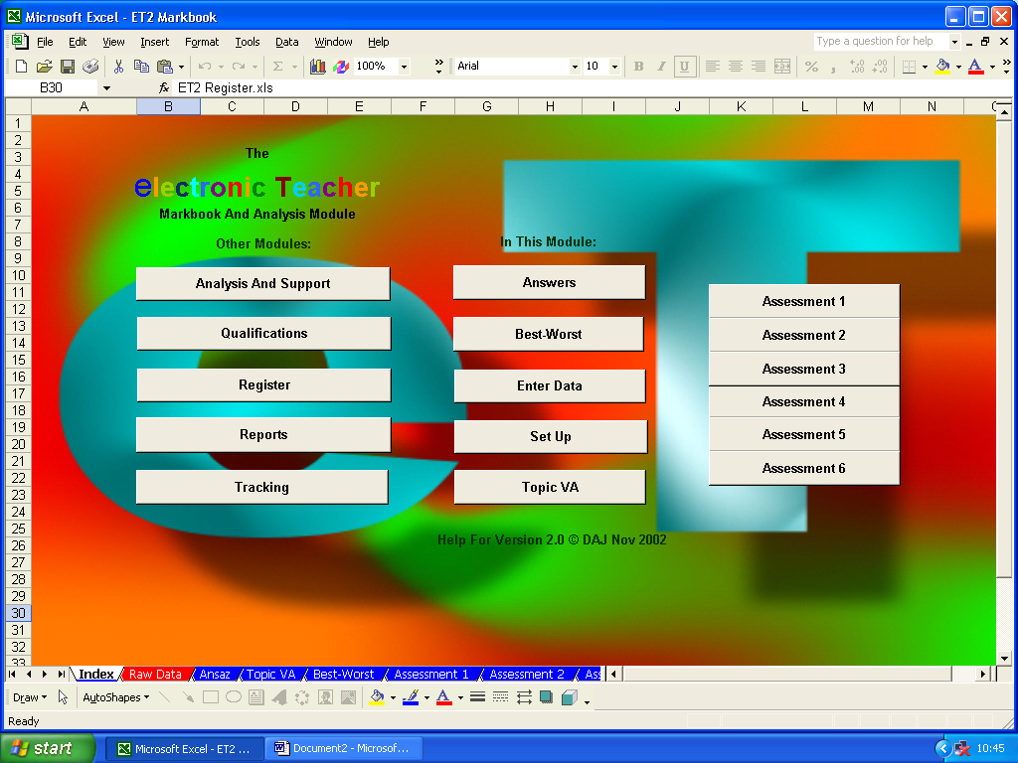

Go To Other Modules Go To Sheets Within The Current Module

Set Up

The Markbook Module is the heart of ET. This is where you define the types of assessment you wish to carry out and enter student details…these will then be automatically transferred to all the other modules…so open up the file ‘ET2 Markbook.xls’ and click on the ‘Set Up’ button.

The ‘Set Up’ sheet currently looks like this…

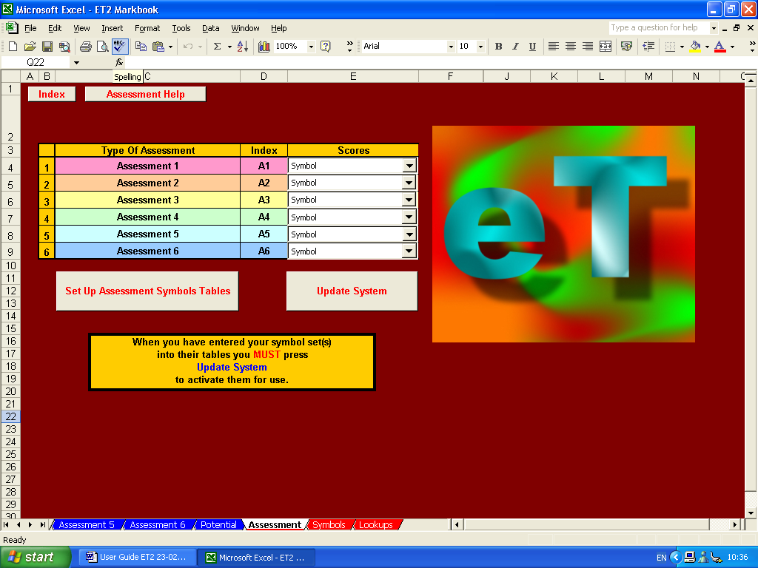

You can choose up to six different types of assessment - which types you use are entirely up to you but, generally, they will be from one of three main forms: Generic, Specific or Diverse.
Generic

Setting up your markbook for generic assessment might mean that you are interested in awarding scores for performance in terms of achievement and effort, as well as assessing behaviour, adherence to rules, etc.

To set up the markbook for this type of assessment, simply click in the cell containing ‘Assessment 1’ and replace this with the name of the first type assessment you wish to carry out. Repeat this for ‘Assessment 2’, etc. and remove the entries for any surplus assessments.

Here ‘Achievement’, ‘Effort’, ‘Behaviour’ and ‘Rules’ have been inserted and the last two surplus cells have been emptied.

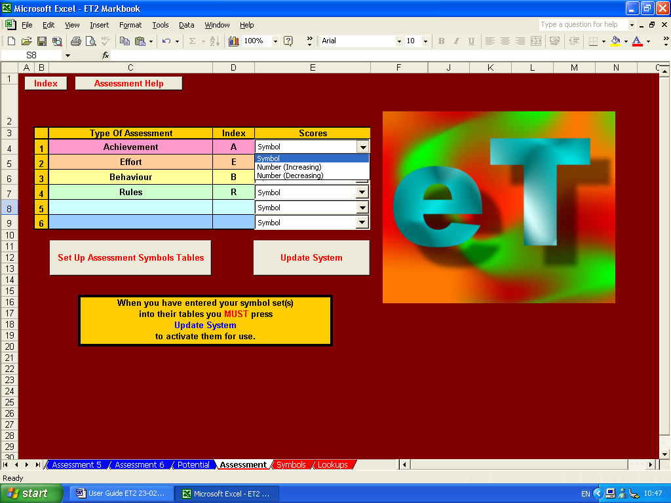

Next, assign an index for each type of assessment. Typically, this should be a single letter, a pair of letters (for instance, if two assessment types begin with the same letter), or some other small code that will be used throughout the markbook, not least to indicate which scores should be aggregated together. Here, the letter ‘A’ will be used to indicate which scores are ‘achievement’ scores. Similarly, ‘E’ for ‘effort’ scores, ‘B’ for ‘behaviour’ scores and ‘R’ for ‘rules’ scores. Surplus indices have been removed.

Now choose what type of score you wish to use for each type of assessment. You have a choice of three main types of scoring system: Number (Increasing), Number (Decreasing) and Symbol.

Number (Increasing) is the most common numericalal scoring system and applies to situations, for instance, where a score of 12 out of 16 is better than a score of 11 out of 16.

Number (Decreasing) is less common but is applied to situations where a final score depends on making a minimum number of errors for a specified set of tasks…2 out of 8, therefore, being better than 3 out of 8, for example.

Symbol is the most versatile and user-definable scoring system and applies to all other types of scores…letter grades (A, B, C…), letter-plus grades (A+, A, A-, B+, B, B-, C+, C…), GCSE/GCE grades (A*, A, B, C…), national curriculum grades (1a, 1b, 1c, 2a, 2b, 2c…), static number grades (1, 2, 3…), etc., etc….

To set up your symbol set, click on the ‘Set Up Assessment Symbols Tables’ button.

As you can see, the tables already show the assessment type name and index at the top…so now simply add the symbol set you wish to use beneath these starting with the highest grade at the top of the column followed by the next highest grade, then the next, etc.…

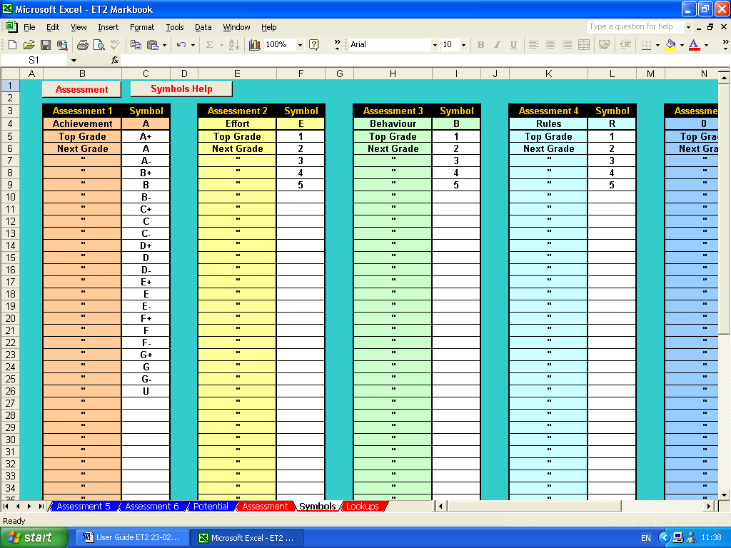

Here, some GCSE grades have been used for achievement scores and static numbers have been used for effort, behaviour and rules scores.

When you have entered all the required symbol sets return to the assessment set up sheet by clicking on the ‘Assessment’ button in the top left-hand corner.

Finally, you need to click on the ‘Update System’ button to allow ET to update the symbols and other set up details you have entered. Failure to do this may lead to erroneous scoring…so it is imperative not to forget this stage of the set up.

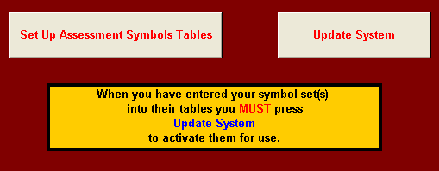

To return to the navigation sheet, click on the ‘Index’ button in the top left-hand corner.

Group Details

Having set up the type of assessment you wish to carry out, it is now time to enter the details of those students you wish to assess. To do this, click on the ‘Enter Data’ button.

The empty ‘Raw Data’ sheet should currently look like this…

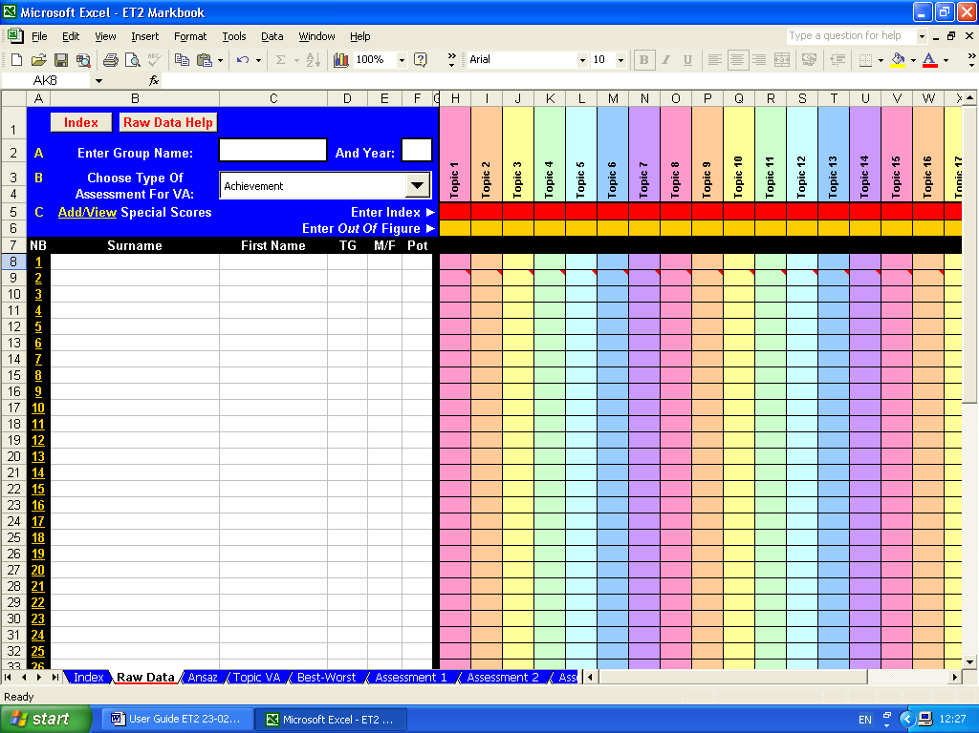

First, enter the name of the teaching group and their year in the relevant white cells.

Then add the details of the group members. For ET to work properly, you will have insert each group member’s surname, first name, tutor or teaching group (‘TG’), gender (‘M/F’) and some numerical indicator of each student’s potential (‘Pot’).

This ‘Pot’ indicator is needed to allow ET to perform its ‘value-added’ analysis.

For most students in primary and secondary phases, this is most likely to be the student’s most recent Cognitive Ability Test (CAT) score.

For 6th form students, you may wish to use an index such as an Advanced Level Information System (ALIS) score.

In fact, any objective numerical indicator of a student’s potential will work here…from an IQ score to any numerical equivalent of an anticipated GCSE, A-level, degree or other pass rate.

However, it is imperative that all members of the group have ‘Pot’ indicators, so where objective CAT scores, etc. may be missing, a considered estimate should be put in its place.

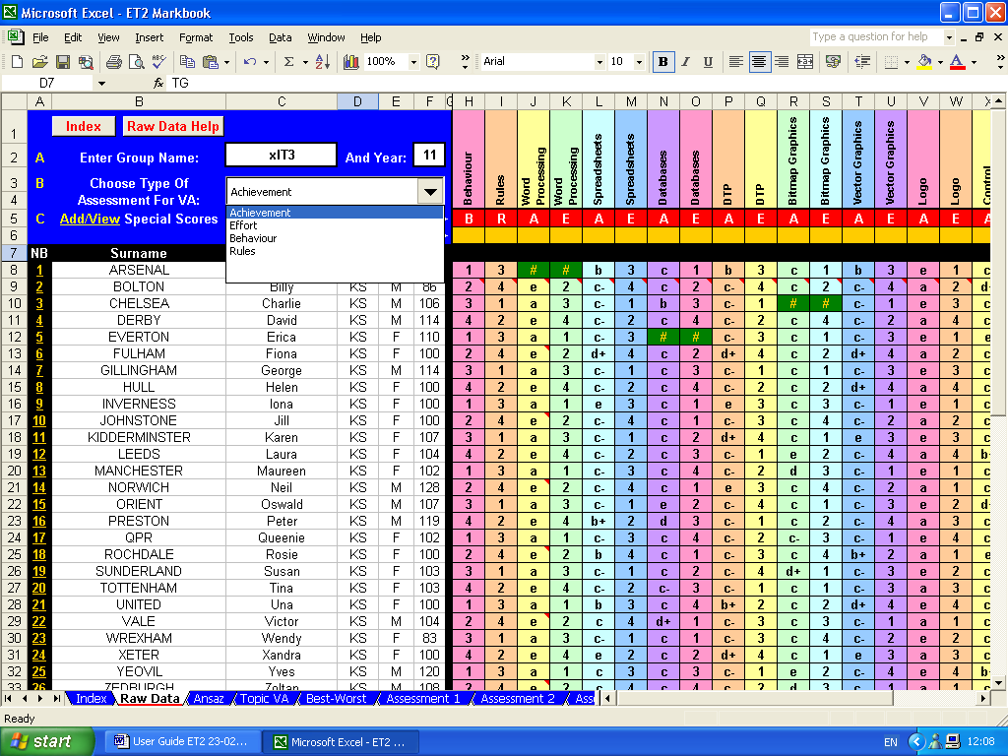

To select which assessment type will be used to calculate ‘value-added’ scores, simply click on the drop-down menu and choose the type required from the list. Here, ‘achievement has been selected.

Student details can be typed in from scratch, however, it is anticipated that, in most cases, the relevant details can be extracted from a school or college information system and then be copied and pasted into ET as appropriate.

ET’s markbook is now ready for day-to-day use.

Each time a new assessment is carried out the following details should be added to ET’s ‘Raw Data’ sheet:

- The name of the current topic or assessment type should be inserted in the top cell of each column;
- The assessment index should be inserted in the appropriate red cell to tell ET what type of assessment this is;
- If the assessment scores are numerical, the relevant ‘out of score’ should be inserted in the appropriate yellow cell
- Finally, individual student scores should be inserted in the relevant rows.

Here, ‘Behaviour’, ‘Rules’, ‘Word Processing’ achievement, ‘Word Processing’ effort, ‘Spreadsheet’ achievement, etc. have been added, together with their appropriate indices…’B’, ‘R’, ‘A’ and ‘E’…on the red row.

As none of the assessment scores in this example are numerical, no ‘out of scores’ have been inserted in the yellow row.

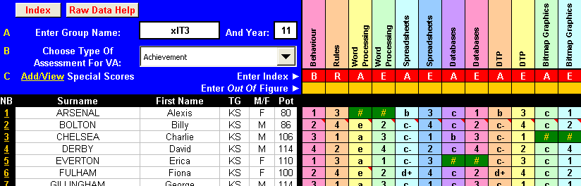

Relevant topic scores can now be added for each individual student. A ‘#’ symbol should be inserted if work is ‘not submitted’ for whatever reason.

Specific

Setting up your markbook for specific assessment might mean that you are interested in awarding scores for performance in terms of well-defined strands or topics. For instance, a secondary technology course may wish to assess student performance in terms of their ability at analysis, design, implementation, testing, evaluation and user documentation.

To set up the markbook for this type of assessment, as before, simply open the ‘Set Up’ sheet and click in the cell containing ‘Assessment 1’ and replace this with the name of the first type assessment you wish to carry out. Repeat this for ‘Assessment 2’, etc.

Appropriate indices should also be inserted and appropriate scoring systems should be selected.

Here assessment titles of ‘Analysis’, ‘Design’, ‘Implementation’, ‘Testing’, ‘Evaluation’ and ‘Documentation’ have been inserted as have appropriate indices of ‘A’, ‘De’, ‘I’, ‘T’, ‘E’ and ‘Do’.

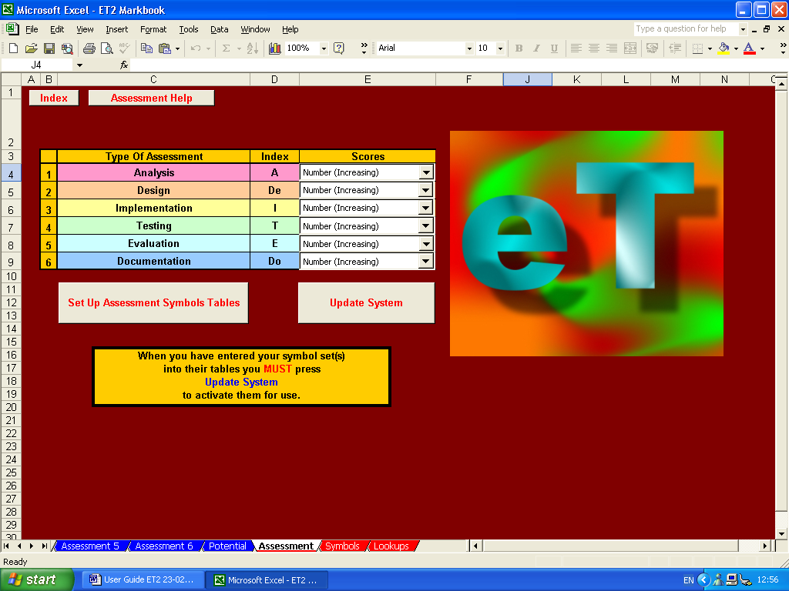

Increasing numbers have been chosen throughout as the scoring system and, as such, no symbol sets need to be defined.

Group and individual student details can now be added as above and a type of assessment can be designated for calculating value-added analysis. Here, implementation has been chosen for this task.

Again, topic titles and assessment titles should be inserted in the top cell of each column, assessment indices inserted in the red row, and ‘out of scores’ should be inserted, where appropriate in the yellow row. Here, ‘Table Lamp’, table lamp ‘Analysis’, table lamp ‘Design’, etc. have been added, together with their appropriate indices…’A’, ‘De’, ‘I’ and ‘E’, etc.…on the red row.

As the assessment scores in this example are numerical, relevant ‘out of scores’ have also been inserted in the yellow row.

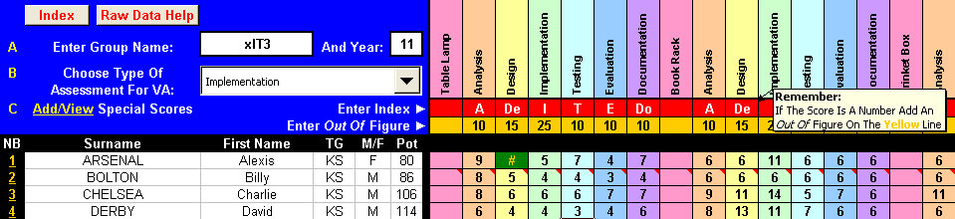

Relevant topic scores can now be added for each individual student and, as before, a ‘#’ symbol should be inserted if work is ‘not submitted’.
Diverse

ET can cope with a wide variety of assessment types and/or scoring systems and these can live happily together within any particular markbook.

Following the techniques detailed above, here is a markbook set up to accept numbers, letter grades, letter grades with + and – signs, national curriculum grades…even Greek, Arabic and exclamations!

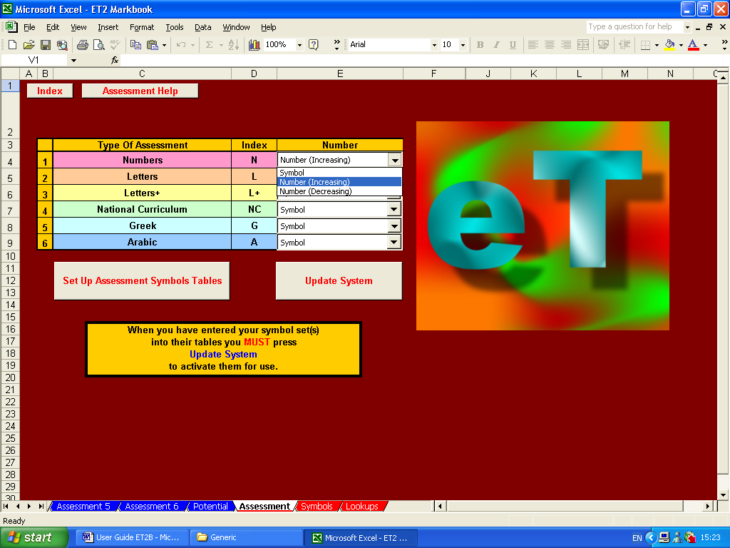

This is how the assessment symbols tables have been set up…again, highest grade at the top of the column, then the next highest grade, then the next, then the next…

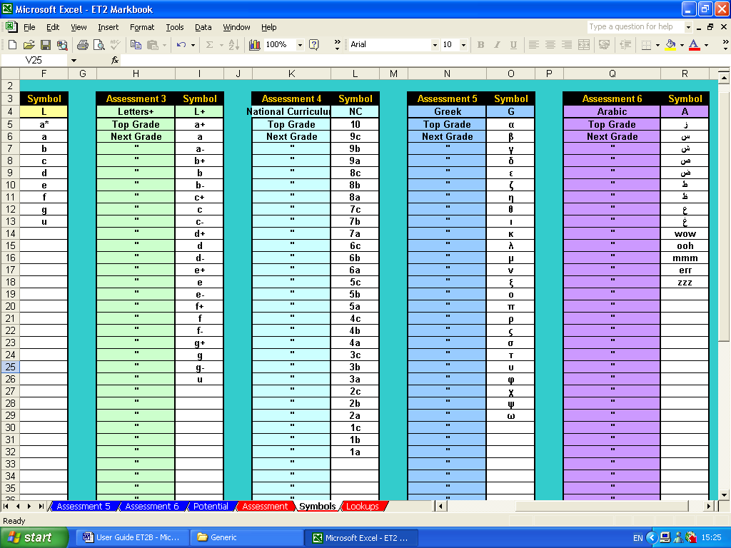

Remember that after the assessment symbol tables have been set up, you must press the ‘Update System’ button if ET is to work correctly.

After this, simply add group, student and topic details as above, together with assessment indices, ‘out of scores’ (where appropriate) and individual scores.

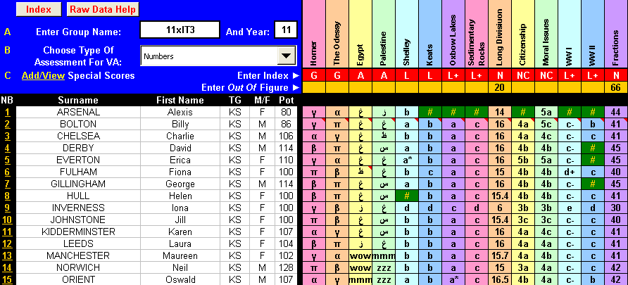

Primary

ET caters for one particularly diverse assessment situation – UK primary phase.

The national curriculum at primary level effective consists of four core subjects (Literacy, Numeracy, Science and IT) and eight foundation subjects (Art, Geography, History, MFL, Music, PE, PSHE and Technology).

ET’s primary modules split this workload into two easily manageable sections.

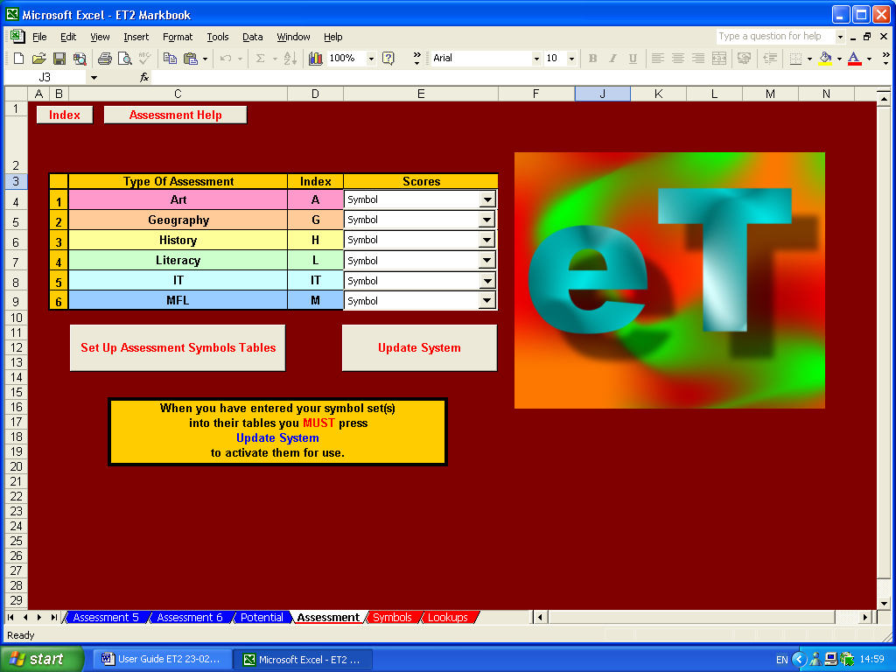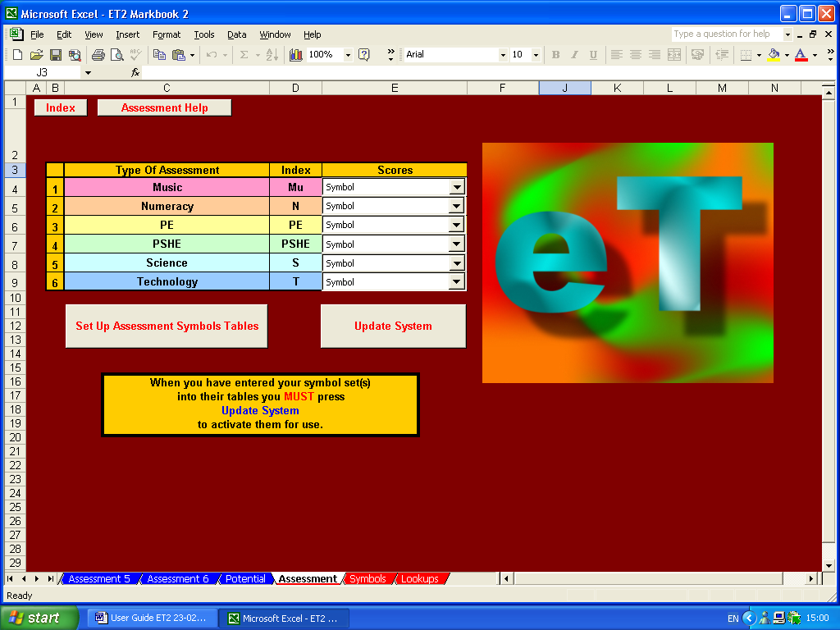

These have already been set up to identify national curriculum subjects as assessment types (Art, Geography, History, etc.); have been given appropriate assessment indices (‘A’, ‘G’, ‘H’, etc.); and appropriate symbol tables to accept national curriculum grades (1a, 1b, 1c, 2a, etc.)
If you wish to use ET’s primary modules, all that remains is for you enter group and individual student details and choose the type of assessment to be designated for calculating value-added analysis. Here, this is Mrs Smith’s Year 5 group and literacy has been chosen as the assessment to be used for value-added calculations.

Again, topic titles should be inserted in the top cell of each column, assessment indices inserted in the red row. Here, ‘Portrait’, ‘Seaside Study’, etc. have been added, together with their appropriate indices…’A’, ‘G’, etc.

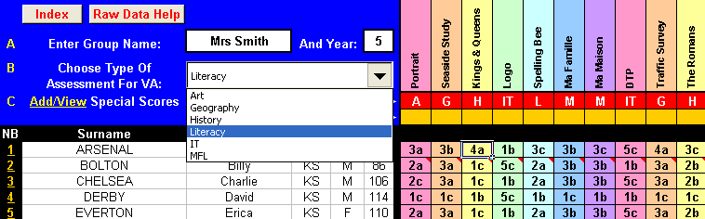

That should be it…finished! Your markbook, whatever its precise type and contents, should now be set up.

If nothing else, ET has already provided an easily manageable, high quality, electronic method of recording your assessment of students and it might well be worth using ET solely for this purpose. However, ET does much more than this…and here is where ET more than repays your efforts to date and starts to earn its corn….

Formative And Performance Analysis

Click on the ‘Index’ button in the top left-hand corner and return to ET’s main navigation sheet. Now click on the ‘Answers’ button.

Answers

For the purposes of this demonstration, let’s look at the ‘Answers’ sheet for the general, diverse markbook…it will show examples that apply to all the other types of markbook assessment.

First, note that ET has transferred all the group and individual student details needed for this sheet from the raw data sheet. It has also transferred all topic titles, assessment indices, individual symbol scores and ‘not submitted’ (‘#’) marks.

Where numerical scores have been used in the raw data sheet, these have been automatically converted to percentage scores.

This is why including an ‘out of score’ on the yellow row of the raw data sheet is so important…without it an individual number score of, say, 10 is meaningless – 10 ‘out of’ 10 (100%) is impressive, 10 ‘out of’ 100 (10%) not quite so…ET needs it to work out the answer!

ET automatically calculates the group average score for each topic, regardless of whether numbers (increasing or decreasing) or symbols have been used, and this is shown in the black row at the top of each column. This should give an indication of how well this particularly topic was received.

For instance, if the average score is very low, it may be worthwhile considering how this topic might better be delivered in future or what additional resources could be employed at present. If the scores are very high, it may be worthwhile considering using more challenging material.

ET also automatically calculates the individual averages for all the assessment types that have been set up. Here, individual number (‘N’), letter (‘L’), letter+ (‘L+’), national curriculum (‘NC’), Greek (‘G’) and Arabic (‘A’) averages have been calculated and are shown in the black area to the right of the individual student details. The group averages are once more shown on the black row at the top of these columns.

Where letter or letter+ scores have been used, ET automatically highlights C-D borderline average scores in green. This can be used, in the context of GCSE groups for instance, to easily identify students who might significantly benefit from additional attention.

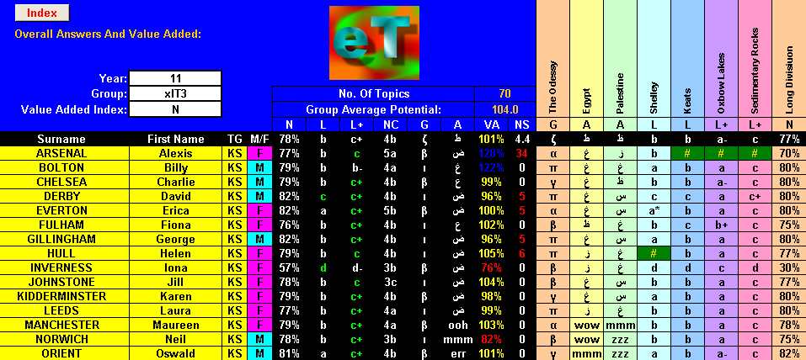

In addition to this, ET calculates the average individual value-added (VA) scores. If a student is performing exactly in-line with expectations they should have a VA score of 100%. VA scores within 10% of this are shown in yellow. Students who are performing more than 10% above expectations are shown in blue, those more than 10% below expectations in red.

Again, ET enables the easy identification of students with exceptional performances, allowing praise or additional attention to be focussed appropriately and effectively

Finally, ET adds up the number of pieces of work that were ‘not submitted’ and where this comes to five or more, these totals are also shown in red…once again, easily highlighting a significant problem so it can be addressed.

If you wish to look at each assessment type individually, return to the main navigation sheet and click on the relevant button…’Assessment 1’ to ‘Assessment 6’.

If, in this example, there is a need to look at, say, the Arabic marks, click on ‘Assessment 6’ and you will be taken to a sheet which only shows details of those topics marked in Arabic.

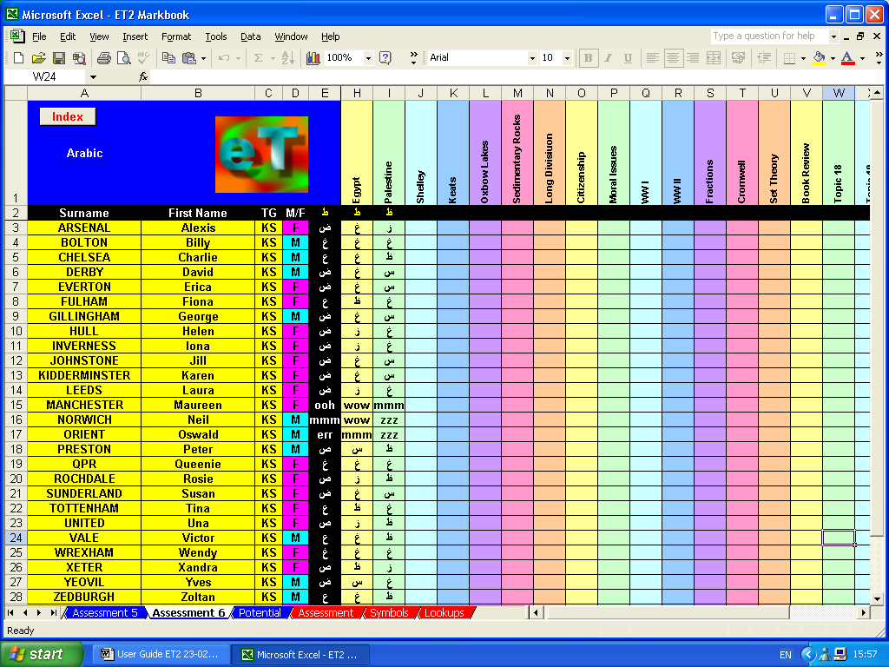

Topic-By-Topic Value-Added

ET’s ability to calculate overall VA scores for each individual student is an extremely valuable tool but, to allow for more formative assessment to take place, it may be still more valuable to calculate value-added on a topic-by-topic basis.

ET does this, again, highlighting scores of more than 110% in blue and less than 90% in red…allowing exceptional performances to be identified and then praised or remedied immediately.

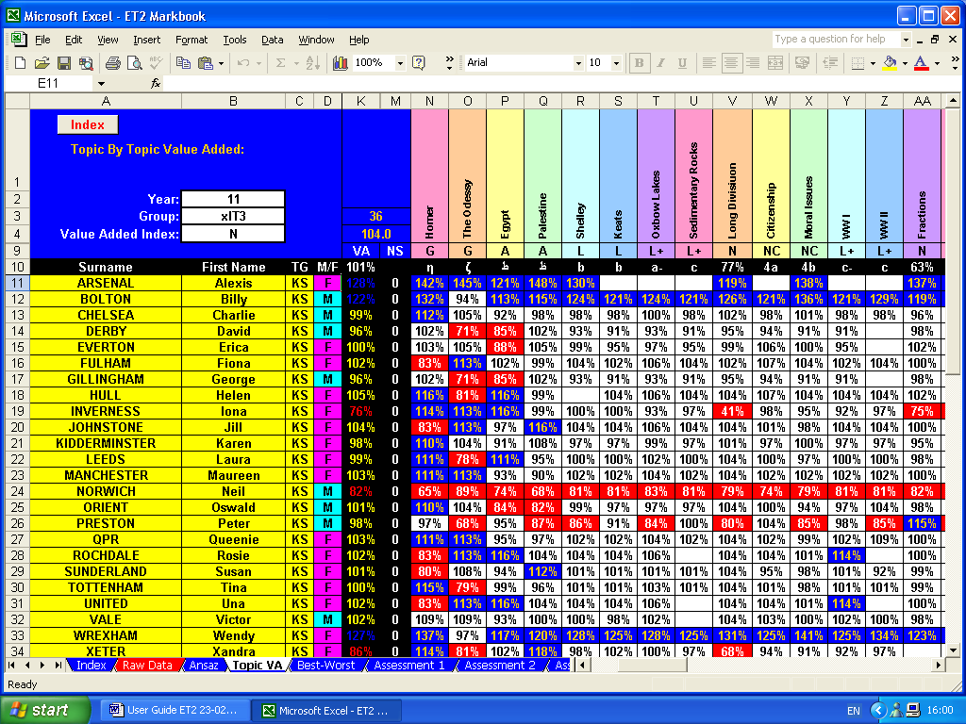
Best-Worst

ET’s ‘Best-Worst’ sheet uses the topic-by-topic VA scores to identify the title of the topics which resulted in the best and worst performances.

Provided informative titles are used to identify topics, these can help in providing a formative assessment of performance.

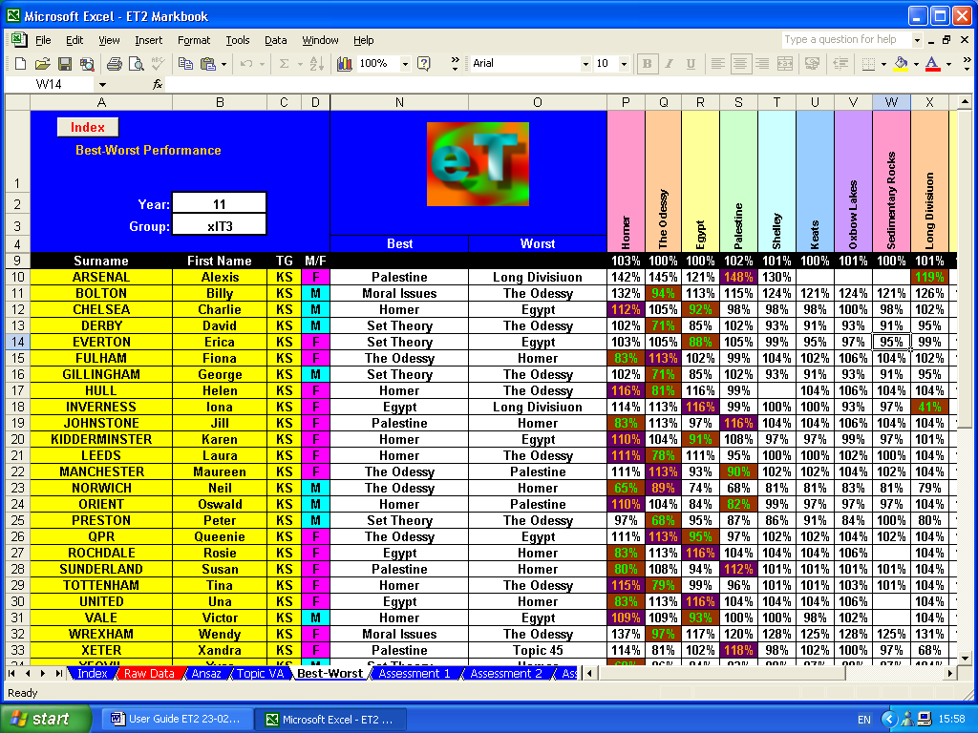

Individual Results

The ‘Individual Results’ sheet displays the average results for each assessment type, together with ‘Best-Worst’ and other data. It also displays VA scores for all topics both in tabular and graphic forms. To select any given student, click on the drop-down menu button and choose the appropriate surname. Alternatively, type in the student’s group number…this can be found in the ‘NB’ column of the ‘Raw Data’ sheet.

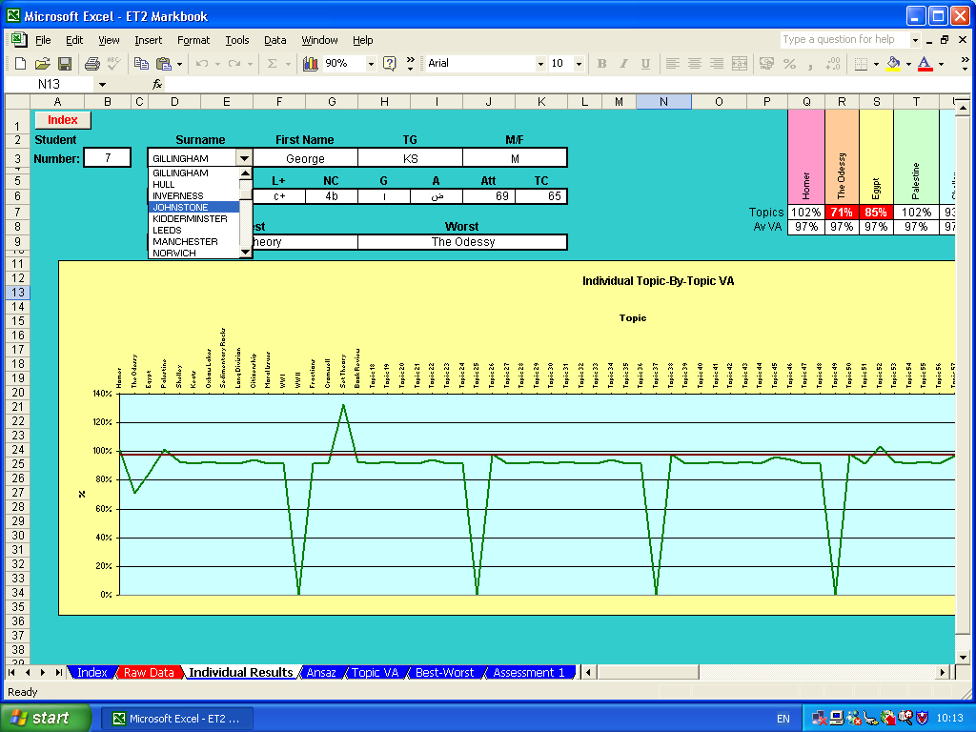

A set up generic markbook is included in the examples folder on the CD.
Rules = wearing correct uniform, bringing right equipment, etc.
ET automatically converts raw number scores (increasing and decreasing) into percentage scores…12 out of 16 thus being converted to 75%.
Symbols which should not be used are ‘#’ which ET’s markbook uses for work ‘not submitted’ and ET’s register uses for a student being late; ‘*’ and ‘?’ which are Excel wildcards; and apostrophes which Excel uses to indicate cell contents should be treated as verbatim.
Static number grades are numbers used as though they were symbols. For instance, one particular piece of work might be allocated an achievement grade of ‘A’ and an effort grade of ‘1’, another ‘A’ ‘2’, a third ‘B’ ‘2’, a fourth ‘B’ ‘1’, etc. In this case, ET’s would return a rounded up average effort grade of ‘1’…not 1.5 or 150%.
ET calculates ‘value-added’ scores very simply by comparing individual performance with group average performance, individual ‘Pot’ score with group average ‘Pot’ score and then comparing the two results: (individual performance ÷ group average performance) ÷ (individual ‘Pot’ score ÷ group average ‘Pot’ score) The theory being that a student with, say, a high CAT score should be expected to perform better relative to one with an average CAT sore. If their performance relative to the group average performance matches their potential relative to the group’s average potential, the above formula should give a value of 1 (100%). If their performance exceeds their potential, the formula will give a score of over 100%, if their performance falls short of their potential, it will give a score of under 100%.
Such as Capita’s Schools Information Management System (SIMS)
As this example uses ‘static numbers’, the numbers in it are treated merely as symbols and, therefore, do not require an ‘out of score’.
Be that, a student has not completed the work, a student was not present when the work was set, or whatever.
A set up specific markbook is included in the examples folder on the CD.
A set up diverse markbook is included in the examples folder on the CD.
Both blank and set up primary markbooks are included on the CD.
Note that this can be changed at any time if identifying value-added on a subject-by-subject basis is required.
This is included on the CD.
Clearly, if, for instance, ET is used with a maths group, it is not going to be informative to identify a best topic as ‘Chapter 7, Exercise 2, Questions 1-9’…however, it may be informative to identify the best topic as ‘Solving Equations’.

